IBM – SQL and Relational Database 101 Certification

# Welcome:

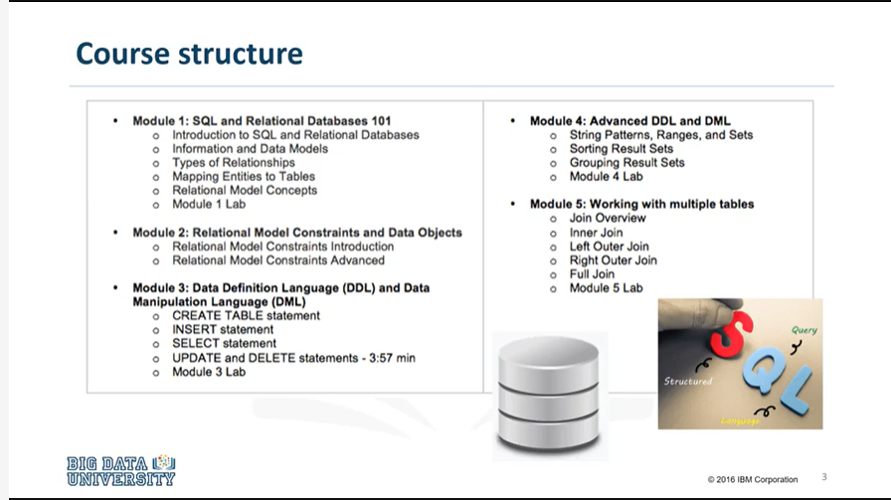

In this course, we’ll learn the relational database model and the basics of the SQL language

# About this course:

## General Information:

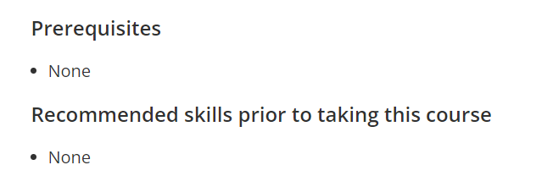

## Learning Objectives:

## **In this course we will learn about:**

* + - the SQL language
    - the relational database model
    - the relational model
    - relational model concepts and constraints

## Syllabus:

**Module 1 - SQL and Relational Databases 101**

* + Introduction to SQL and Relational Databases
  + Information and Data Models
  + Types of Relationships
  + Mapping Entities to Tables
  + Relational Model Concepts

**Module 2 - Relational Model Constraints and Data Objects**

* + Relational Model Constraints Introduction
  + Relational Model Constraints Advanced

**Module 3 - Data Definition Language (DDL) and Data Manipulation Language (DML)**

* + Types of SQL statements (DDL vs. DML)
  + CREATE TABLE statement
  + INSERT statement
  + SELECT statement
  + UPDATE and DELETE statements

**Module 4 - Advanced DDL and DML**

* + String Patterns, Ranges, and Sets
  + Sorting Result Sets
  + Grouping Result Sets

**Module 5 - Working with multiple tables**

* + Join Overview
  + Inner Join
  + Outer Join

# Module 1: SQL and Relational Databases 101

## Learning Objectives:

#### **In this lesson we will learn about:**

* + - SQL and Relational Databases
    - Information and Data Models
    - Types of Relationships
    - Mapping Entities to Tables
    - Relational Model Concepts

## Introduction to SQL and Relational Database:

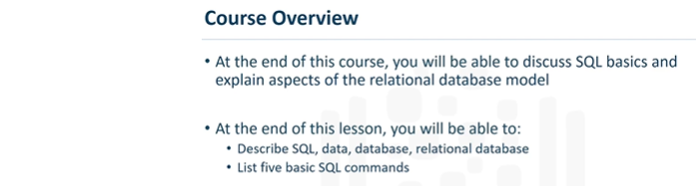

* SQL – is a language used for relational databases to query or get data out of a database. (Structured Query Language)
* SQL is language used in databases to query data

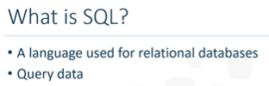

* Data - Data is a collection of facts in the form of words, numbers, or even pictures. Data is one of the most critical assets of any business. It is used and collected practically everywhere.

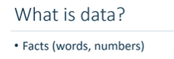

* Database – Data is stored and allow access to these data quickly. Databases are everywhere, and used every day, but they are largely taken for granted. A database is a repository of data. It is a program that stores data. A database also provides the functionality for adding, modifying, and querying that data.
* Different Databases based on requirements.

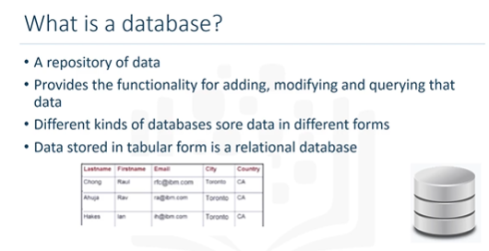

* Relational Database - When data is stored in tabular form, the data is organized in tables, like in a spreadsheet **which is columns and rows. That's a relational database.** The columns contain properties about the item, such as Last Name, First Name, email, address, city. A table is a collection of related things, like a list of employees, or a list of book authors.
* In relational database relationships can be formed between tables.
* DBMS - A set of software tools for the data in the database is called a database management system,
* Relational Databases – the software tools used is called RDBMS. It helps to control the data in relational databases by providing functions like – access, organization and storage
* Examples of RDBMS are – MySQL, Oracle Database, DB2 Express C
* 5 standard command which is used for working in a database.

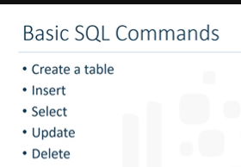

## Information Models and Data Models:

* Learn about different models.

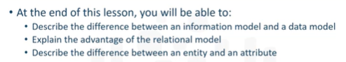

* This figure illustrates the relationship between an Information Model and a Data Model.

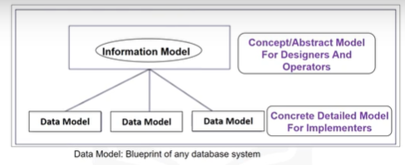

* Information Model - is an abstract, formal representation of entities that includes their properties, relationships and the operations that can be performed on them. The entities being modeled can be from the real world, such as a library.
* **Information Models and Data Models are different and serve different purposes.** An Information Model is at the conceptual level, and defines relationships between objects. Data Models are defined at a more concrete level, are specific and include details. A data model is the blueprint of any database system.
* There are several types of Information Models. The most popular is
* the Hierarchical - typically used to show organization charts.

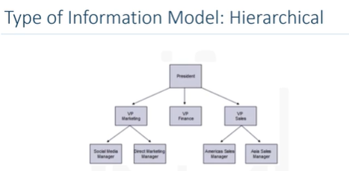

* As shown is in this figure, the hierarchical model organizes its data using a tree structure. The root of the tree is the parent node followed by child nodes. A child node cannot have more than one parent, however, a parent can have many child nodes.
* The first hierarchical database management system was the Information Management System **released by IBM in 1968** and was originally built as the database for the Apollo space program.
* The Relational Model is the most used data model for databases because this model allows for data independence. Data is stored in a simple data structure, tables. This provides logical data independence, physical data independence, and physical storage independence.

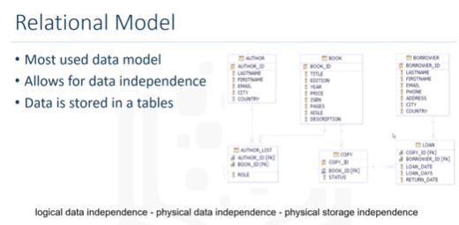

* **An Entity-Relationship Data Model, or ER Data Model, is an alternative to a relational data model.**
* **Using a simplified library database as an example,** this figure shows an Entity-Relationship Diagram, or ERD, that represents entities (called tables) and their relationships.
* We have authors who write books, borrowers who take books out on loan, various copies of each book, etc. This is the final ER diagram. But how do we get there?
* An Entity-Relationship Model proposes thinking of a database as a collection of entities. Rather than being used as a model on its own, the ER Model is used as a tool to design relational databases.

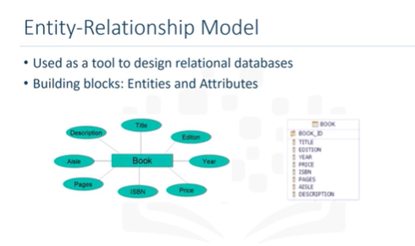

* In the ER Model, entities are objects that exist independently of any other entities in the database. It is simple to convert an ER Diagram into a collection of tables.
* The building blocks of an ER Diagram are entities and attributes. Entities have attributes, which are the data elements that characterize the entity. Attributes tell us more about the entity.
* **In an ER Diagram, an entity is drawn as a rectangle, and attributes are drawn as ovals.**
* Entities can be a noun (person, place, or thing). Using a simplified library as an example, a book is an example of an entity. Attributes are certain properties or characteristics of an entity, and tell us more about the entity.
* The entity Book has attributes such as book title, the edition of the book, the year the book was written, etc. Attributes are connected to exactly one entity. The entity Book becomes a table in the database, and the attributes become the columns in a table.
* Continuing the simplified library example, books are written by authors. Book is an entity, and Author is an entity .

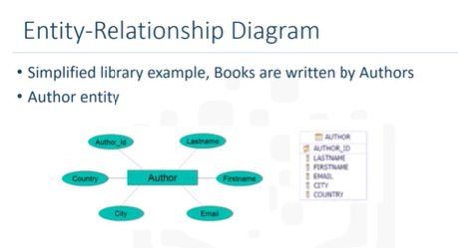

* For the entity Author, the ER Diagram would look like this.
* The entity Author has attributes such as the author's last name, first name, email, city, country and an author ID (to uniquely identify the author). The entity Author becomes a table in the database, and the attributes become the columns in the table.
* In the simplified library database, we progress through the process of identifying entities, such as borrowers who take books out on loan, various copies of each book, and copies of books out on loan.

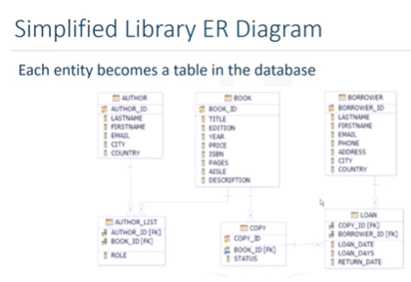

* This is the final ER Diagram. Each entity becomes a table in the database.

## Types of Relationships:

* In this video, we will provide an overview of the relationships that exists between entities.

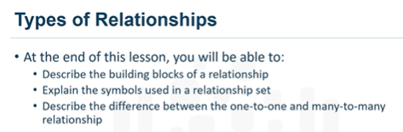

* At the end of this lesson, you will be able to describe the building blocks of a relationship, explain the symbols used in a relationship set, and describe the difference between the one-to-one and many-to-many relationship.
* The building blocks of a relationship are: entities, relationship sets, and crows foot notations.

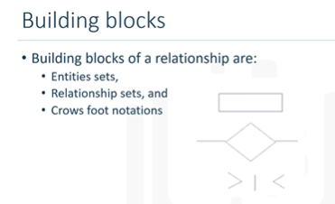

* **Entity sets are represented by a rectangle.**
* **Relationship sets are represented by a diamond.**
* **The lines connecting associated entities.**
* Different techniques are used in representing relationships. For ease of understanding, this lesson uses the **crows foot notations.**
* Some of these are the greater-than symbol, the less-than symbol and a vertical line.
* An Entity-Relationship diagram, or ER diagram, for the entity book would look like this.

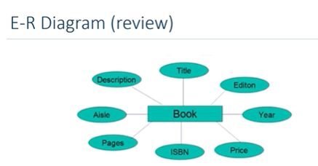

* The entity, Book, is drawn as a rectangle, and the attributes are drawn as ovals. Attributes are certain properties of that entity, for example title, edition, year, price, etc. Attributes are connected to exactly one entity.

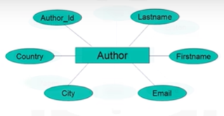

* For the entity Author, the ER diagram would look like this. The entity Author has attributes last name, first name, email, city, country and author ID.
* Let's see how the entities Book and Author relate to each other.

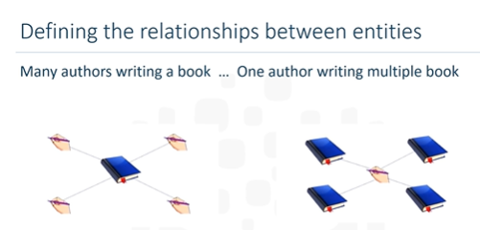

* A book must be written by at least one author. However, a book can be written by two authors, and a book can be written my many authors.
* As another example, one author can write just one book, or two books or multiple books.
* In both cases, there is a relationship between the book and the author.
* In our examples we see that a book needs at least one author.

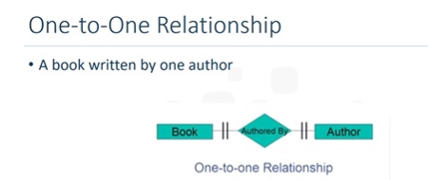

* The relationship set that comes here is authored-by. One book must be written by one author. The thick lines indicate each entity in the entity set is involved in at least one and exactly one relationship. **This is called a one-to-one relationship**. Only entities are used in the relationship diagrams. Attributes are omitted because they can clutter the diagrams.
* Earlier we saw that more than one author can write a book.

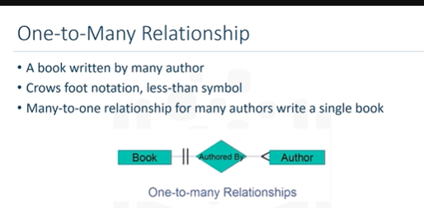

* **This can be represented with a different notation called crows foot notation.** In this case, a less than symbol. This indicates, that one book entity is participating in more than one relationship in the relationship set. **This is called a one-to-many relationship.**
* **This could also be called a many-to-one relationship in that many authors write a single book.**

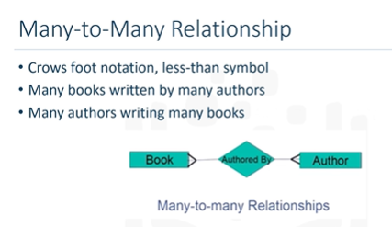

* To represent many authors writing many books, use the greater-than and less-than symbols on either side of the relationship set. **This is called a many-to-many relationship**.
* Each entity in the entity set is participating in more than one relationship. Many books being written by many authors, or, many authors writing many books.

## Mapping Entities to tables:

* In this video, we will learn how entities are mapped to relational database tables.

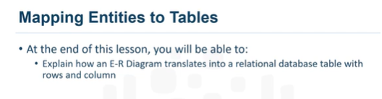

* Entity Relationship Diagrams are the basic foundation for designing a database.

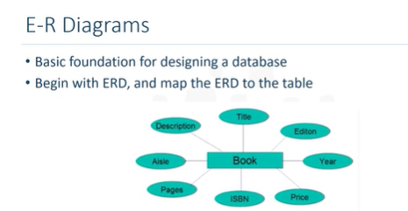

* In the relational database design, begin with an ER diagram, or ERD, and later map the ERD to the tables in a database.
* In this example, we use the ERD for entity Book.

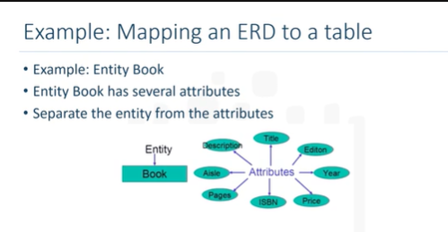

* Entity Book has several attributes. The entity and its attributes will be mapped to a table.
* For ease of understanding, lets separate the entity from the attributes.

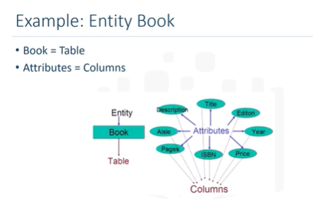

* In this case, entity Book becomes a table with the same name Book. All the attributes translate into columns in the table.
* We will now see how a table would be represented in a Relational database model.

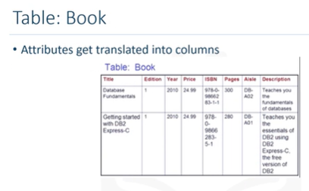

* A table is a combination of rows and columns. While mapping, the entity becomes the table. Having said that, the table has not yet taken the form of rows and columns. The attributes get translated into columns in a table providing the actual table form of rows and columns.
* Later we add some data values to each of the columns, which completes the table form.

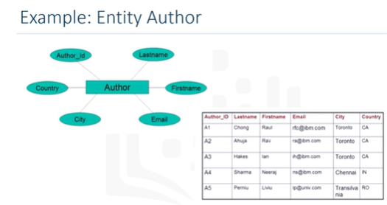

* For the Author example, the entity Author becomes the table, and the attributes get translated to columns in the table. Adding some data values into the columns complete the table.

## Relational Model Concepts:

* In this video, we will learn the history of the relational model, and some relational terms.

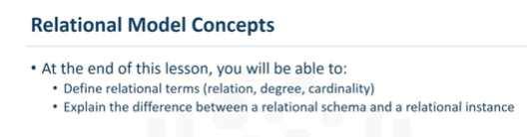

* **The relational model was first proposed in 1970**, and is based on a mathematical model and mathematical terms.

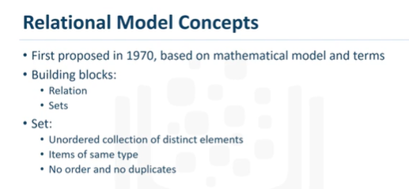

* The building blocks of the Relational Model are - Relation and Sets.
* The Relational Model of data is based on the concept of relation.
* Relation - A relation is a mathematical concept based on the idea of sets.
* Set - A set is an unordered collection of distinct elements. It is a collection of items of the same type. It would have no order and no duplicates.
* A relational database is a set of relations. **A relation is also the mathematical term for a table.**

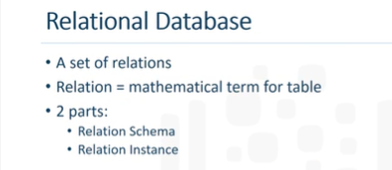

* A table is a combination of rows and columns.
* **A Relation is made up of 2 parts: Relational Schema and Relational Instance.**
* **The Relational Schema specifies**: the name of a relation, name and type of each of the columns, which are the attributes.
* The example here is the entity Author.

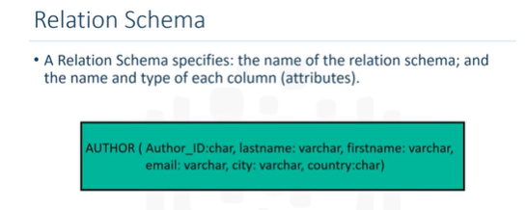

* Author is the name of the relation. Author_ID is an attribute which can hold the data type char, which is a character string of a fixed length. Likewise last name, first name, email and city have the data type varchar, which is a character string of a variable length. The last attribute, Country, also has a data type of char. This constitutes the Relational Schema.
* **A Relational Instance** is a table made up of rows and columns. The columns are the attributes, or fields. The rows are tuples.

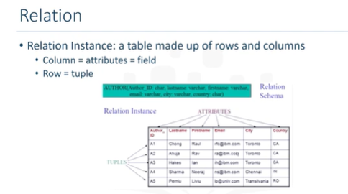

* **Degree** refers to the number of attributes, or columns, in a relation.
* **Cardinality** refers to the number of tuples, or rows.
* In this example, the Degree is 6 because there are 6 columns, and the Cardinality is 5 because there are 5 tuples, or rows.

## Assignment 1:

In this module, you learned that Entity-Relationship Diagrams are a tool to design relational databases, and the concepts of a relational model including the terms entity, attribute, degree, and cardinality. Now let us try and apply the concepts we have learned in this module to a real-world example of a database. We will be working on a relational database schema called Car dealership. The diagram below shows the schema diagram for the Car Dealership relational database schema.

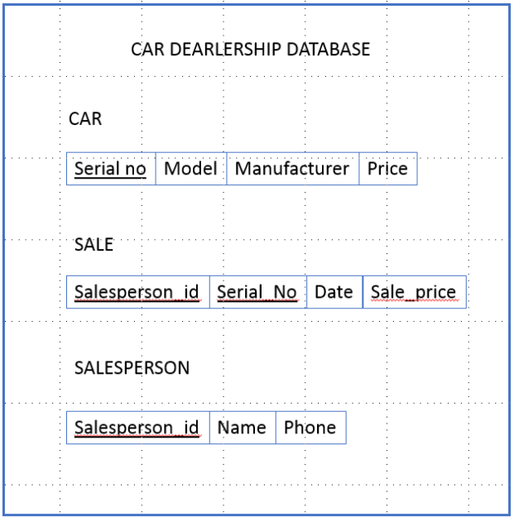

A database must be designed to keep track of automobile sales in a car dealership. Please answer the following questions based on the above schema. The answers to these questions are given on the next page.

Question 1: How many relations does the Car dealership Schema contain? 3

Question 2: How many columns does the relation Car contain? 4

Question 3: What is the degree of the relation Salesperson? 3

## Lab:

### Setting up the Lab Environment:

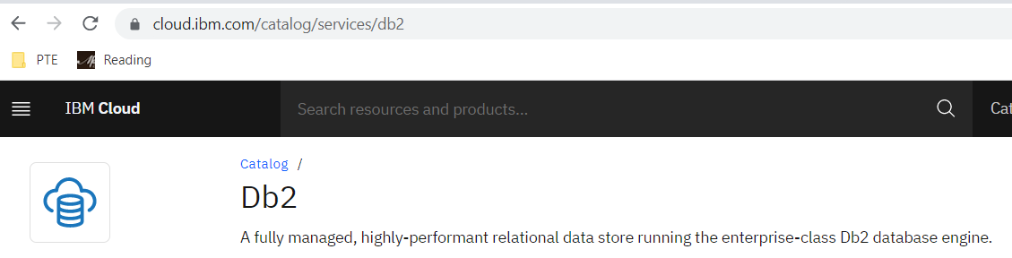

## Test:

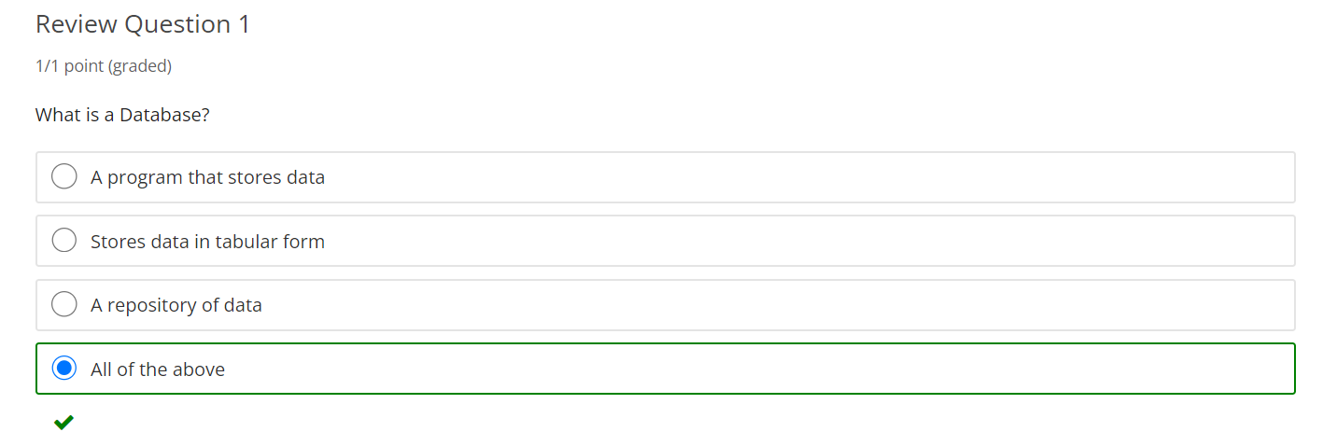

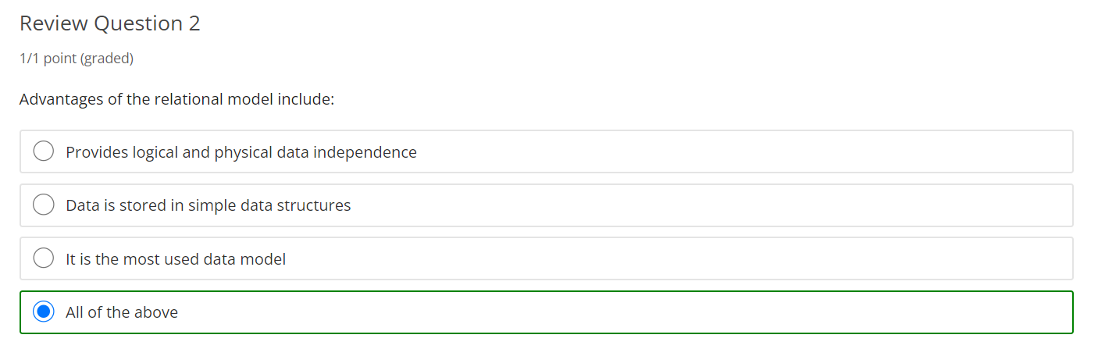

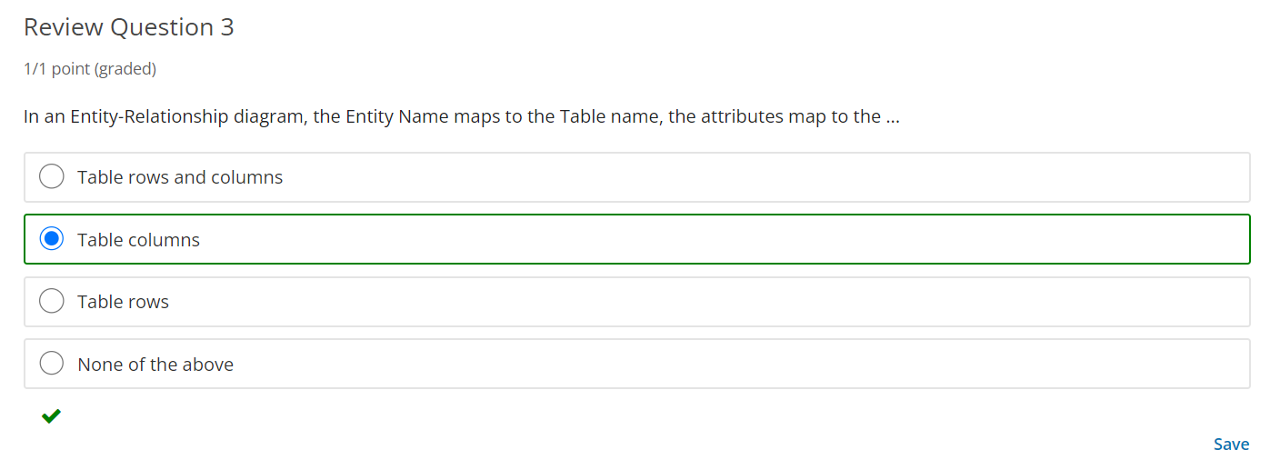

# Module 2: Relational Model Constraints and Data Objects:

## Learning Objectives:

#### In this lesson you will learn about:

* + - Relational Model Constraints Introduction
    - Relational Model Constraints Advanced

## Relational Model Constraints Introduction:

We will learn about referencing between entities and we will learn some new terminology that is used in a relational model.

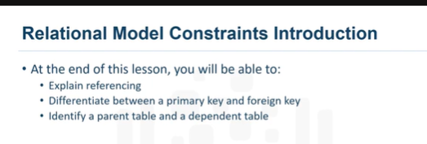

* Within any business, data must adhere to certain restrictions or rules.

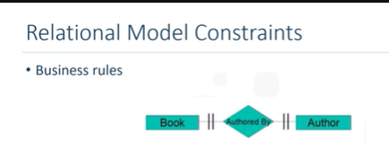

* In this lesson, we will use the Book and Author example.
* At least one author writes one book. This is a one-to-one relationship. To look up the Author information, the Book entity refers to the Author entity. To look up the Book information, the Author entity refers to the Book entity.
* In a relational data model this is **called referencing.**

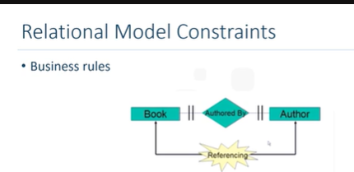

* In relational databases, this establishes the data integrity between two relations.
* The Entity-Relationship Diagram represents the Relational Data Model for the Author entity and Book entity as part of a simplified library database model. Other entities have been added, such as Borrower, Loan, Copy, and Author List.

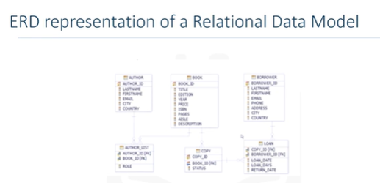

* Notice that the attributes Author_ID, Book_ID, and Borrower_ID have a special icon. This identifies the Primary Key.
* **A Primary Key** of a relational table uniquely identifies each row in a table.
* Notice the entities on the lower half of the screen.
* Some attributes have FK in brackets next to them. For example, the Copy entity has attribute Book_ID with the FK in brackets. This identifies the Foreign Key.
* **A Foreign Key** is a set of columns referring to a primary key of another table. These entities are part of the relationship set between the entities above them. All of the entities have a one-to-many relationship established between them.
* Let's learn a couple of new terms that are used in a relational model.

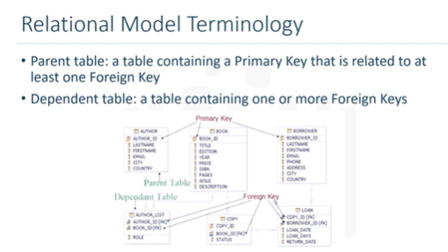

* In the example, the Author entity is the parent table. The Book entity is also a parent table. A table containing one or more foreign keys is called a dependent table. It might also be referred to as a child table. In the example, the Author_List entity has foreign keys that refer to different parent tables, Author and Book.

## Relational Model Constraints Advanced:

* In this video, we will learn about the six constraints in a relational database model.

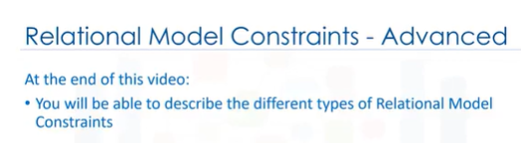

* Within any business, data must often adhere to certain restrictions or rules. **Constraints help implement the business rules.**
* In a relational data model, data integrity can be achieved using integrity rules or constraints. The following six constraints are defined in a relational database model:

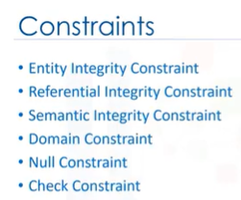

* To identify each, topple in a relation, the relation must have a primary key. The primary key is a unique value that identifies each topple or row in a table. **This is the entity integrity constraint.**

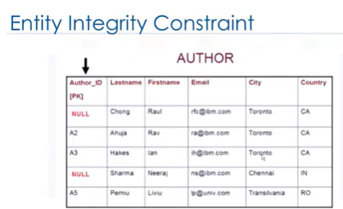

* **The terms primary and key constraint or unique constraint are also used.** This constraint prevents duplicate values in a table.
* To implement these constraints, indexes are used. The entity integrity constraint states that no attribute participating in the primary key of a relation is allowed to accept null values. The value null indicates that the value is unknown.
* In the entity integrity constraint, the primary key cannot have an unknown value. For example, in the relation author, author_ID is the primary key.
* The primary key identifies each topple in the relation. The author_IDA1 points to author Raul Chong from Toronto. If we replace the value A1 with null, we can still identify the author as Raul Chong. However, if we also replace author_IDA4 with null, now we do not know which null value identifies which topple.
* With the entity integrity constraint, no attribute participating in the primary key is allowed to accept null values.
* **Referential integrity constraint** defines relationships between tables and ensures that these relationships remain valid.

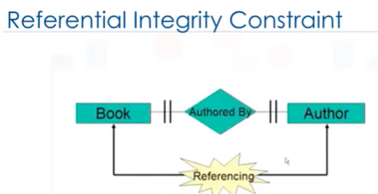

* The validity of the data is enforced using a combination of primary keys and foreign keys.
* As mentioned previously, for a book to exist, it has to be written by at least one author.
* **The semantic integrity constraint** refers to the correctness of the meaning of the data.

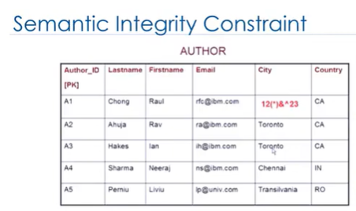

* For example, in the relation author, if the attribute or column city contains a garbage value instead of Toronto, the garbage value does not have any meaning.
* The semantic integrity constraint is related to the correctness of the data.
* **A domain constraint** specifies the permissible values for a given attribute.

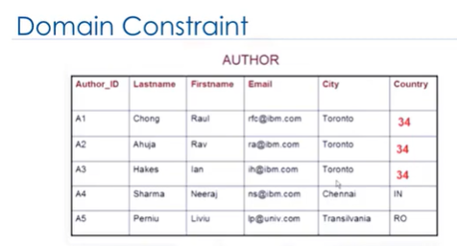

* For example, in the relation author, the attribute country must contain a two-letter country code such as CA for Canada or IN for India. If a number value of 34 is entered for the country attribute instead of a two-letter country code, the value 34 does not have any meaning.
* As we saw previously, the entity integrity constraint states that no attribute participating in the primary key is allowed to accept null values.

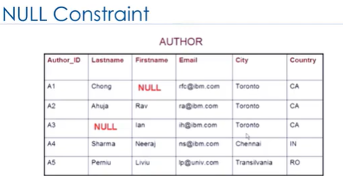

* **The null constraint specifies that** attribute values cannot be null.
* For example, in the relation author, if either last name or first name contains a null value, it could be difficult to identify the correct author. In this example, first name and last name attribute values cannot be null, and author must have a name.
* **The check constraint enforces** domain integrity by limiting the values that are accepted by an attribute.

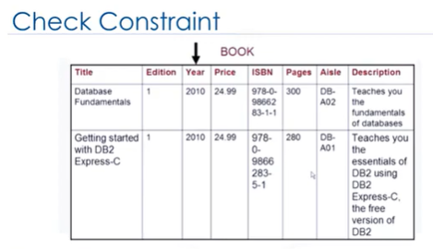

* The relation author does not have a suitable attribute to explain the check constraint, so we will use the relation book. In the relation book, the attribute year is the year in which a particular book is published. If this was still the year 2010, it would not be meaningful to have a year greater than the current year.
* The check constraint would enforce the domain integrity by limiting the values that are accepted by the attribute year.

## Additional Information:

### Primary Keys

If a relation schema has more than one key, then each key is called a **candidate key.** One of the candidate keys is designated as the primary key, and the others are called **secondary keys.**

In a practical relational database, each relation schema must have a primary key.

#### **Rules for primary keys:**

The value of the Primary Key must be unique for each instance of the entity.

* There can be no missing values( ie. Not Null) for Primary Keys. If the Primary Key is composed of multiple attributes, each of those attributes must have a value for each instance.
* The Primary Key is immutable.i.e., once created the value of the Primary Key cannot be changed.
* If the Primary Key consists of multiple attributes, none of these values can be updated.

### Semantic Integrity

**Semantic integrity ensures that data entered a row reflects an allowable value for that row.** The value must be within the domain, or allowable set of values, for that column. For example, the quantity column of the items table permits only numbers. If a value outside the domain can be entered into a column, the semantic integrity of the data is violated.

### Semantic Constraints

Semantic Constraints are constraints that cannot be directly expressed in the schemas of the data model. **Semantic constraints are also called application-based rules or business rules.** They are additional rules specified by users or database administrators. For example, a class can have a maximum of 30 students; salary of an employee cannot exceed the salary of the employee’s manager.

**Domain constraints specify** that within a tuple the value of each attribute must be an element from the domain of that attribute. The data types associated with the domains include:

* Integers (short integer, integer, long integer)
* Real numbers (float and double precision float)
* Characters
* Booleans
* Fixed-length strings and variable length strings
* Date, time, timestamp
* Money
* Other special data types

Other possible domain values may be a sub-range of values from a data type or as an enumerated data type in which values are explicitly listed.

## Assignment 2:

In this module, you learned about relational model constraints. Now let us try and apply the concepts we have learned in this module to a real world example of a database. We will be working on a relational database schema called Car dealership. The diagram below show the schema diagram for the Car Dealership relational database schema.

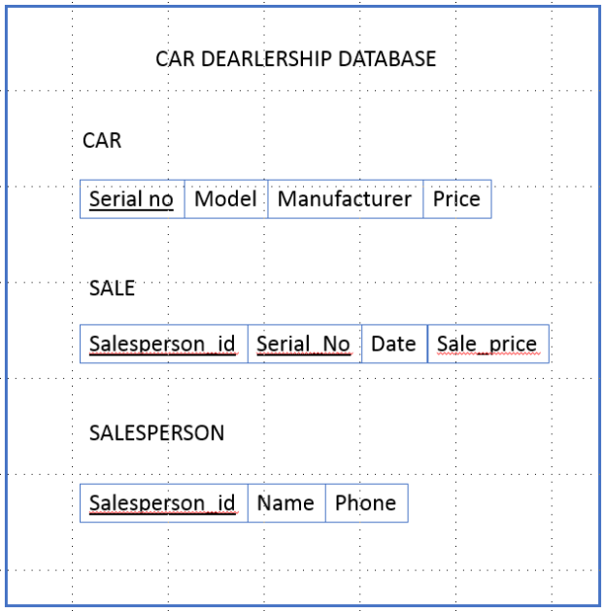

A database must be designed to keep track of automobile sales in a car dealership. Please, answer the following questions based on the above schema.

Question 1: Identify the primary key of the relation Car. – Serial no

Question 2: Identify the foreign key of the relation Sale. – Serial no

Question 3: How many constraint types are there in relation Sale? – 2 (primary and foreign key constraints)

## Lab 2:

Created Table and loaded data in table.

## Test 2:

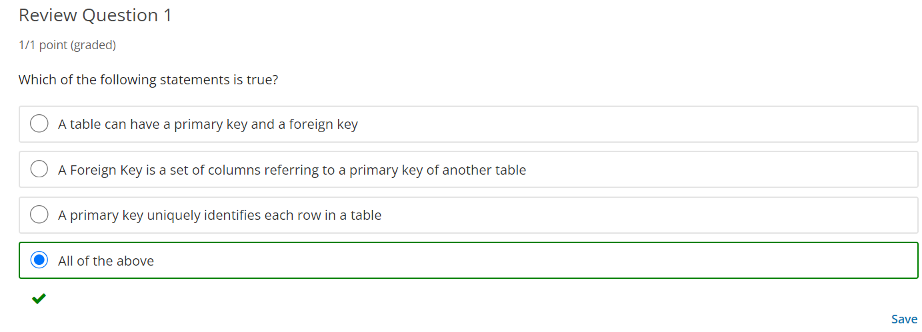

Lab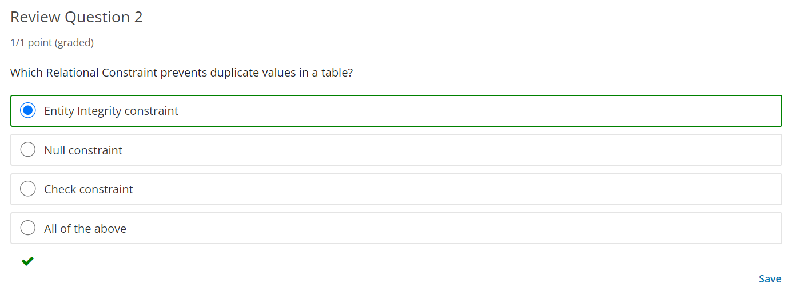

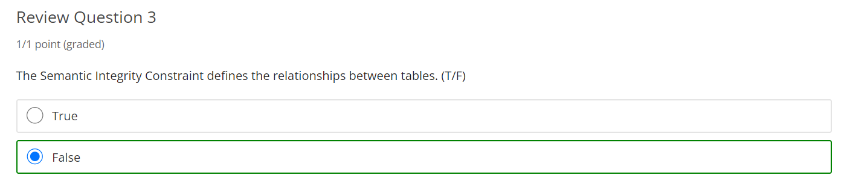

# Module 3: Data Definition Language (DDL) and Data Manipulation Language (DML)

## Learning Objectives:

#### In this lesson you will learn about:

* + - Types of SQL statements (DDL vs. DML)
    - CREATE TABLE statement
    - INSERT statement
    - SELECT statement
    - UPDATE and DELETE statements

## Types of SQL statements (DDL vs. DML)

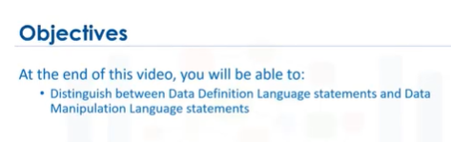

* SQL Statements are used for interacting with Entities (that is, tables), Attributes (that is, columns) and their tuples (or rows with data values) in relational databases.

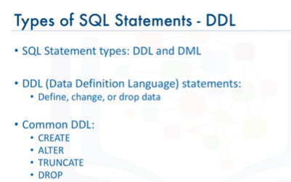

* **SQL statements fall into two different categories**: Data Definition Language statements and Data Manipulation Language statements.
* **DDL** -Data Definition Language (or DDL) statements are used to define, change, or drop database objects such as tables. Common DDL statement types include CREATE, ALTER, TRUNCATE, and DROP.
* **CREATE:** which is used for creating tables and defining its columns;
* **ALTER:** is used for altering tables including adding and dropping columns and modifying their datatypes;
* **TRUNCATE:** is used for deleting data in a table but not the table itself;
* **DROP:** is used for deleting tables.

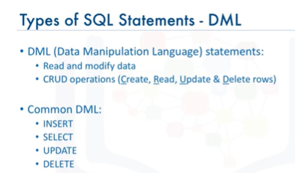

* **DML -** Data Manipulation Language (or DML) statements are used to read and modify data in tables. These are also sometimes referred to as **CRUD operations,** that is, Create, Read, Update and Delete rows in a table.
* Common DML statement types include INSERT, SELECT, UPDATE, and DELETE.
* **INSERT:** is used for inserting a row or several rows of data into a table;
* **SELECT**: reads or selects row or rows from a table;
* **UPDATE**: edits row or rows in a table;
* **DELETE**: removes a row or rows of data from a table.

## CREATE TABLE statement

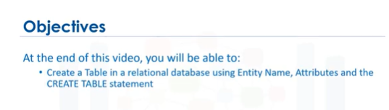

* CREATE The syntax of the CREATE table is shown here:

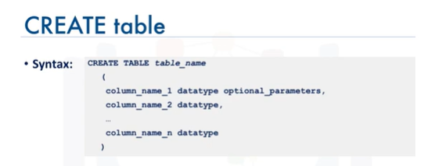

* Each attribute or column definition is separated by a comma.
* For example, if we want to create a table for provinces in Canada you would specify:

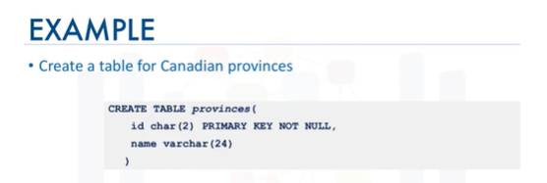

* In this example, **the data types used are:** CHAR which is a character string of a fixed length, in this case 2. And VARCHAR, which is a character string of a variable length. In this case, this variable character field can be up to 24 characters long. Issuing this statement would create a table in the database with 2 columns.
* The first column id for storing the abbreviated 2 letter province short codes such as AB , BC, etc. And the second column called name for storing the full name of the province, such as ALBERTA, BRITISH COLUMBIA, etc.

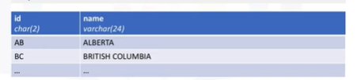

* Now, let’s look at a more elaborate example based on the Library database. This database includes several entities such as AUTHOR, BOOK, BORROWER, etc.

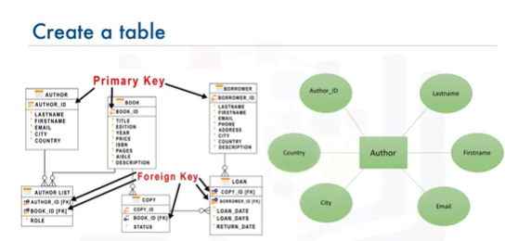

* Let’s start by creating the table for the AUTHOR entity. The name of the table will be AUTHOR, and its attributes such as AUTHOR_ID, FIRSTNAME, LASTNAME, etc. will be the columns of the table.
* In this table, we will also assign the **Author_ID attribute as the Primary Key**, so that no duplicate values can exist. Recall, the Primary Key of a relational table uniquely identifies each tuple (or row) in a table.
* To create the Author table, issue the following command:

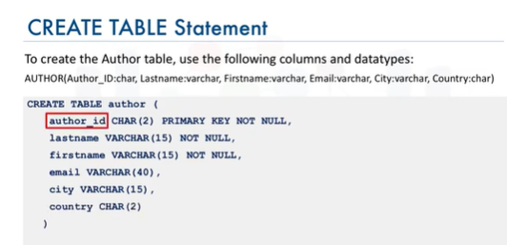

* Note that the Author_ID is the Primary Key. This constraint prevents duplicate values in the table.
* Also note that Last Name and First Name have the constraint NOT NULL.

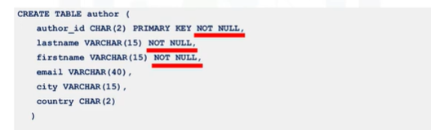

* This ensures that these fields cannot contain a NULL value, since an author must have a name.

## INSERT statement

In this video, we will learn about populating a relational database table.

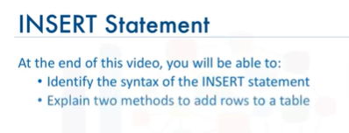

* After table is created, the table needs to be populated with data. To insert data into a table, we use the INSERT statement. The INSERT statement is used to add new rows to a table. The INSERT statement is one of the data manipulation language statements.
* Data manipulation language statements or DML statements are used to read and modify data. Based on the author entity example, we created the table using the entity name author, and the entity attributes as the columns of the table.

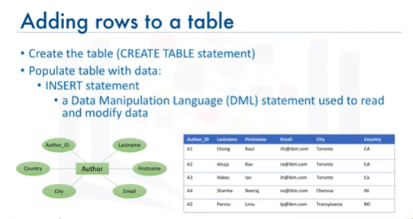

* Now we will add the data to the author table by adding rows to the table. To add the data to the author table, we use the INSERT statement. The syntax of the INSERT statement looks like this,

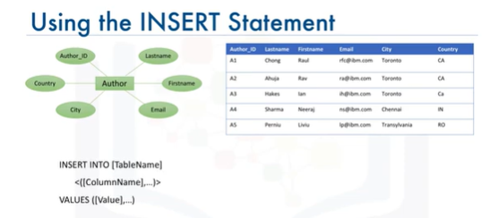

* In this statement, table name identifies the table, the column name list identifies each column in the table, and the values clause specifies the data values to be added to the columns in the table.
* To add a row with the data for Raul Chong.

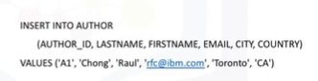

* The author table has six columns, so the INSERT statement lists the six column names separated by commas, followed by a value for each of the columns also separated by commas.
* It is important that the number of values provided in the values clause is equal to the number of column names specified in the column name list. This ensures that each column has a value.
* Tables do not need to be populated one row at a time, multiple rows can be inserted by specifying each row in the values clause. In the values clause, each row is separated by a comma.
* For example, in this INSERT statement we are inserting two rows, one for Raul Chong and one for Rav Ahuja.

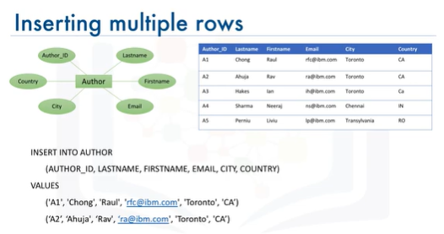

## SELECT statement

* In this video, we will learn about retrieving data from a relational database table by selecting columns of a table.

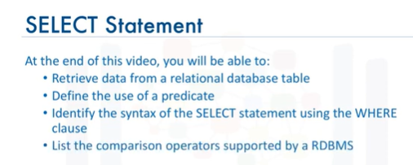

* The main purpose of a database management system is not just to store the data but also facilitate retrieval of the data. So, after creating a relational database table and inserting data into the table, we want to see the data.
* To see the data, we use the SELECT statement.
* The SELECT statement is a data manipulation language statement.
* Data Manipulation Language statements or DML statements are used to read and modify data.
* The SELECT statement is called a **query**, and the output we get from executing this query is called a **result set or a result table.**

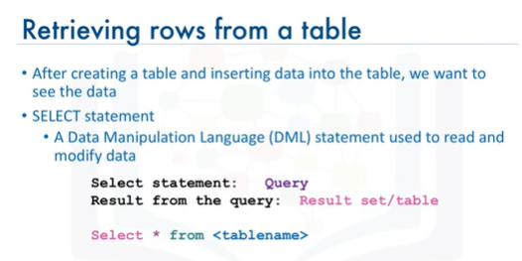

* Based on the book entity example, we would create the table using the entity name book and the entity attributes as the columns of the table. The data would be added to the book table by adding rows to the table using the insert statement.
* In the book entity example, All the data rows for all columns in the table book are displayed.

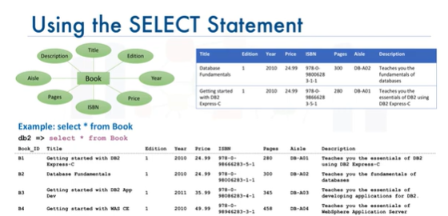

* In addition, you can also retrieve all the rows for all columns by specifying the column names individually in the SELECT statement. You don't always have to retrieve all the columns in a table. You can retrieve just a subset of columns. If you want, you can retrieve just two columns from the table book.
* For example book_id and title. In this case, the select statement is

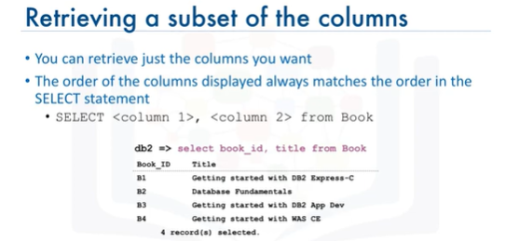

* In this case, only the two columns display for each of the four rows. Also notice that the order of the columns displayed always matches the order in the SELECT statement.
* However, what if we want to know the title of the book whose book_id is B1. Relational operation helps us in restricting the result set by allowing us to use the clause WHERE. The WHERE clause always requires a predicate.A predicate is conditioned evaluates to true, false or unknown. Predicates are used in the search condition of the WHERE clause.
* So, if we need to know the title of the book whose book_id is B1,

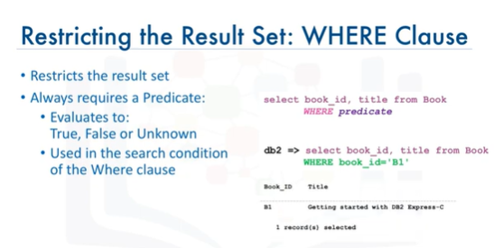

* Notice the result set is now restricted to just one row whose condition evaluates to true.
* The previous example used comparison operator equal to in the WHERE clause. There are other comparison operators supported by a relational database management system:

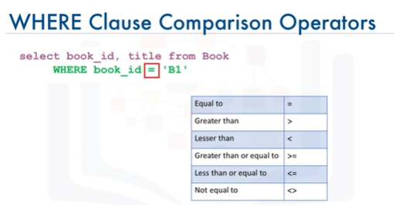

## UPDATE and DELETE statement

* In this video, we will learn about altering and deleting data in a relational database table.

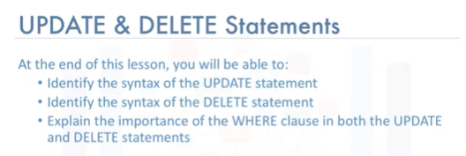

* After a table is created and populated with data, the data in a table can be altered with the UPDATE statement.
* The UPDATE statement is one of the data manipulation language or DML statements. DML statements are used to read and modify data.
* Based on the author entity example, we created the table using the entity name

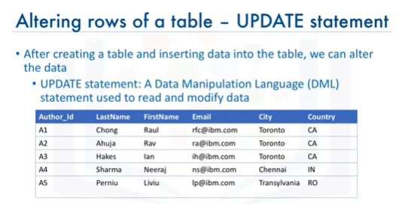

* Author and the entity attributes as the columns of the table. Rows were added to the Author table to populate the table. Sometime later, you want to alter the data in the table. To alter or modify the data in the Author table, we use the UPDATE statement.
* The syntax of the UPDATE statement looks like this,

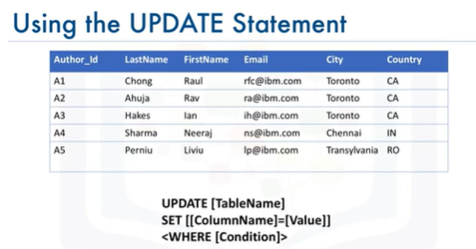

* Let's look at an example. In this example, you want to update the FIRSTNAME and LASTNAME of the author with AUTHOR_ID A2 from Rav Ahuja to Lakshmi Katta.
* In this example, to see the UPDATE statement in action, we start by selecting all rows from the author table to see the values. To change the first name and last name to Lakshmi Katta where the AUTHOR_ID = A2, enter the UPDATE statement as follows.
* 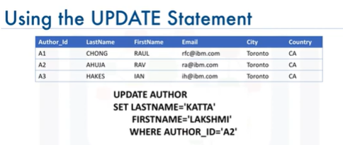
* Now, to see the result of the update,

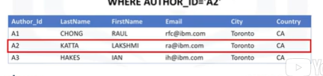

* Note that if you do not specify the WHERE clause, all the rows in the table will be updated.
* In this example, without specifying the WHERE clause all rows in the table would have changed the first and last names to Lakshmi Katta.
* Sometime later, there might be a need to remove one or more rows from a table. The rows are removed with the DELETE statement. The DELETE statement is one of the data manipulation language statements used to read and modify data. The syntax of the DELETE statement looks like this,

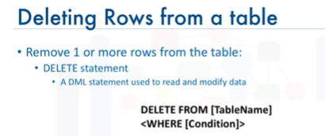

* Based on the author entity example, we want to delete the rows for AUTHOR_ID A2 and A3.
* Let's look at an example.

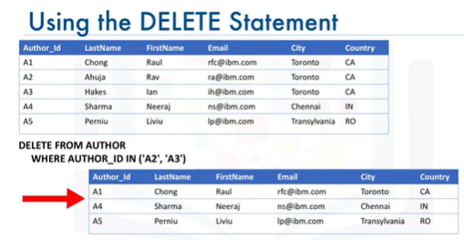

* Note that if you do not specify the WHERE clause, all the rows in the table will be removed.

## Lab 3

**Task 0:** Drop the table INSTRUCTOR from the database in case it already exists, so that we start from a clean state.

(Hint: Ignore the undefined error if this table does not already exist in your database)

**Task 1:** Create the INSTRUCTOR table as defined above. Have the ins_id be the primary key, and ensure the lastname and firstname are not null.

(Hint: ins_id is of type INTEGER, country of type CHAR(2), and rest of the fields VARCHAR)

**Task 2A:** Insert one row into the INSTRUCTOR table for the the instructor Rav Ahuja.

(Hint: values for the character fields require a singe quotation mark (') before and after each value)

**Task 2B:** Insert two rows at once in the INSTRUCTOR table for instructors Raul Chong and Hima Vasudevan.

(Hint: list the values for the second row after the first row)

**Task 3:** Select all rows from the INSTRUCTOR table.

**Task 3B:** Select the firstname, lastname and country where the city is Toronto

**Task 4:** Update the row for Rav Ahuja and change his city to Markham.

**Task 5:** Delete the row for Raul Chong from the table.

**Task 5B:** Retrieve all rows in the INSTRUCTOR table

## Test 3

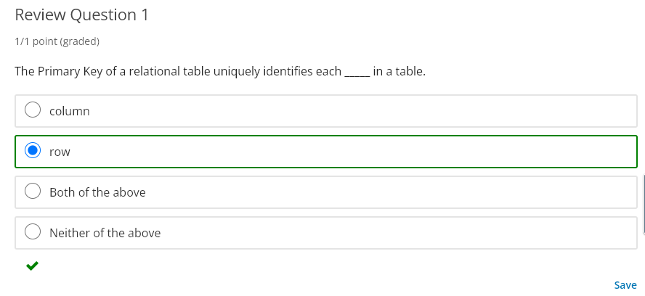

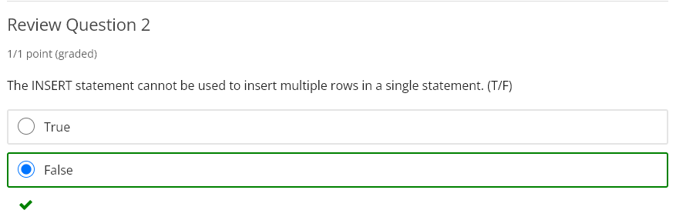

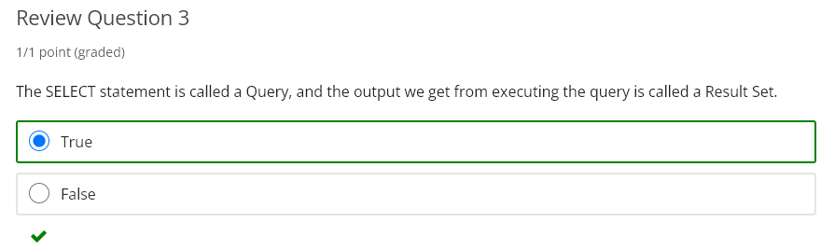

# Module 4:

## Learning Objectives:

#### In this lesson you will learn about:

* + - String Patterns, Ranges, and Sets
    - Sorting Result Sets
    - Grouping Result Sets

## String Patterns, Ranges, and Sets

* Welcome to retrieving data with SELECT statement string patterns. In this video we will learn about some advanced techniques in retrieving data from a relational database table.

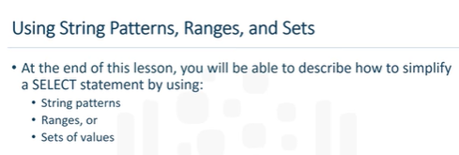

* The main purpose of a database management system is not just to store the data, but also facilitate retrieval of the data.
* In its simplest form, a SELECT statement is: select * from tablename. Based on our simplified library database model, and the table Book, select * from book gives a result set of four rows. All the data rows for all columns in the table Book are displayed.

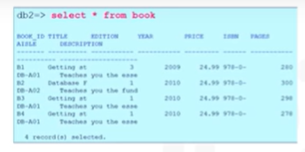

* Or you can retrieve a subset of columns, for example, just two columns from the table Book, such as book_id and title. Or you can restrict the result set by using the WHERE clause. For example, you can select the title of the book whose book_id is B1.

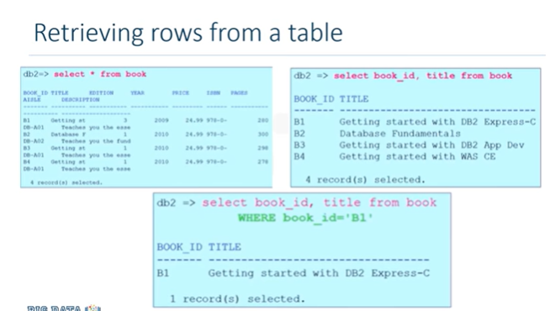

* But what if we don't know exactly what value to specify in the WHERE clause?
* The Where clause always requires a predicate, which is a condition that evaluates to true, false or unknown. But what if we don?t know exactly what value the predicate is?
* For example, what if we can't remember the name of the author, but we remember that their first name starts with R?
* In a relational database, we can use string patterns to search data rows that match this condition.

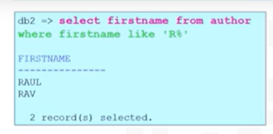

* Lets look at some examples of using string patterns. If we can't remember the name of the author, but we remember that their first name starts with R, we use the Where clause with the LIKE predicate. The LIKE predicate is used in a WHERE clause to search for a pattern in a column. The percent sign is used to define missing letters. The percent sign can be placed before the pattern, after the pattern, or both before and after the pattern.
* In this example, we use the percent sign after the pattern, which is the letter R. The percent sign is called a **wildcard character.** A wildcard character is used to substitute other characters.
* So, if we can't remember the name of the author, but we can remember that their first name starts with the letter R, we add the LIKE predicate to the Where clause.
* For example, shown in image
* This will return all rows in the Author table whose authors first name starts with the letter R. And here is the result set. Two rows are returned for authors Raul and Rav.
* What if we wanted to retrieve the list of books whose number of pages is more than 290 but less than 300.
* We could write the select statement like this,

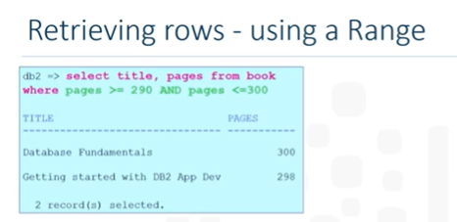

* But in a relational database, we can use a range of numbers to specify the same condition.
* Instead of using the Comparison Operators greater-than or equal to, we use the Comparison Operator BETWEEN AND. BETWEEN AND compares two values. The values in the range are inclusive.
* In this case, we re-write the query to specify the WHERE clause as: WHERE pages BETWEEN 290 AND 300. The result set is the same, but the SELECT statement is easier and quicker to write.
* In some cases there are data values that cannot be grouped under ranges.
* For example, if we want to know which countries the authors come from. If we wanted to retrieve authors from Australia or Brazil, we could write the SELECT statement with the WHERE clause repeating the two country values. However, what if we want to retrieve authors from Canada, India, and China? The WHERE clause would become very long repeatedly listing the required country conditions.
* Instead, we can use the IN operator. The IN operator allows us to specify a set of values in a WHERE clause. This operator takes a list of expressions to compare against. In this case, the countries Australia or Brazil.

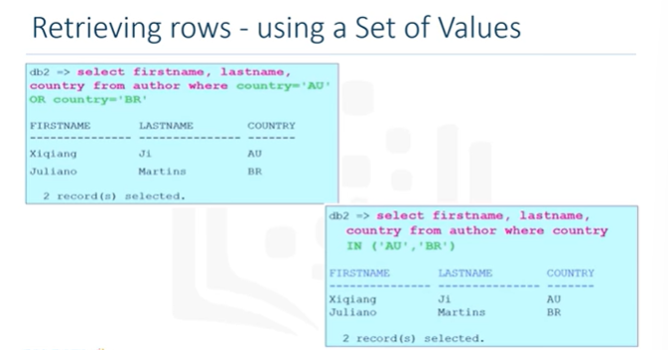

## Sorting Result Sets

* Hello and welcome to sorting SELECT statement result sets. In this video we will learn about some advanced techniques in retrieving data from a relational database table and sorting how the result set displays.

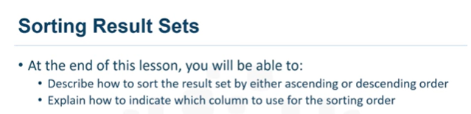

* The main purpose of a database management system is not just to store the data, but also facilitate retrieval of the data.
* In its simplest form, a SELECT statement is: select * from tablename. Based on our simplified library database model, and the table Book, select * from book gives a result set of four rows. All the data rows for all columns in the table Book are displayed.
* We can choose to list the book titles only, as shown in this example, select title from book. However, the order does not seem to be in any order. Displaying the result set in alphabetical order would make the result set more convenient.

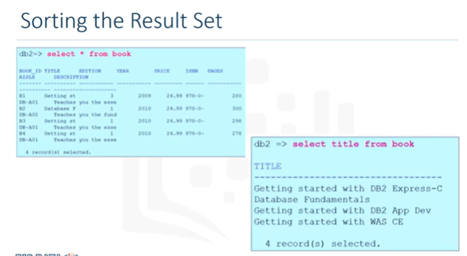

* To do this, we use the ORDER BY clause. To select the result set in alphabetical order, we add the ORDER BY clause to the SELECT statement.
* The ORDER BY clause is used in a query to sort the result set by a specified column. In this example, we have used ORDER BY on the column Title to sort the result set. By default, the result set is sorted in ascending order. In this example, the result set is sorted in alphabetical order by book title.

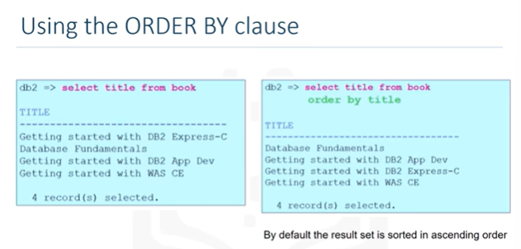

* To sort in descending order, we use the keyword DESC. The result-set is now sorted according to the specified column , which is Title, and is sorted in descending order. Notice the order of the first three rows.

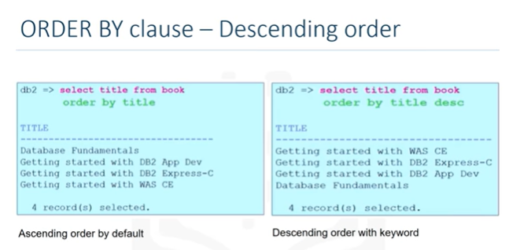

* The first three words of the title are the same. So, the sorting starts at the point where the characters differ.
* Another way of specifying the sort column is to indicate the column sequence number. In this example,

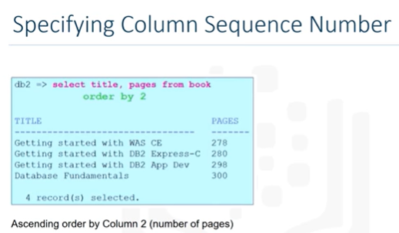

* Instead of specifying the column name Pages, the number 2 is used. In the SELECT statement, the second column specified in the column list is "Pages", so the sort order is based on the values in the Pages column. In this case, the Pages column indicates the number of pages in the book. As you can see, the result set is in an ascending order by number of pages.

## Grouping Result Sets

* Hello, and welcome to grouping SELECT statement result sets. In this video we will learn about some advanced techniques in retrieving data from a relational database table, and sorting and grouping how the result set displays.

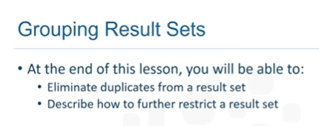

* At times, a SELECT statement result set can contain duplicate values. Based on our simplified library database model, in the Author table example the Country column lists the two-letter country code of the authors country. If we select just the Country column, we get a list of all the countries.
* For example, SELECT Country from Author ORDER BY 1.

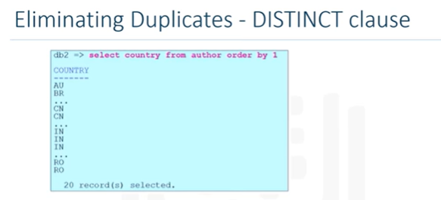

* The ORDER BY clause sorts the result set. This result set lists the countries that authors belong to, sorted alphabetic ally by Country. In this case, the result set displays 20 rows, one row for each of the 20 authors. But some of the authors come from the same country. So, the result set contains duplicates.
* However, all we need is list of countries that authors come from. So, in this case, duplicates do not make sense. **To eliminate duplicates, we use the keyword DISTINCT. Using the keyword DISTINCT reduces the result set to just 6 rows.**

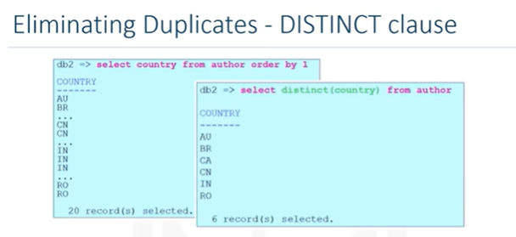

* But what if we wanted to also know how many authors come from the same country? So, now we know that the 20 authors come from 6 different countries. But, we might want to also know how many authors come from the same country. To display the result set listing the country and number of authors that come from that country, we add the GROUP BY clause to the SELECT statement.
* The GROUP BY clause groups a result into subsets that has matching values for one or more columns.

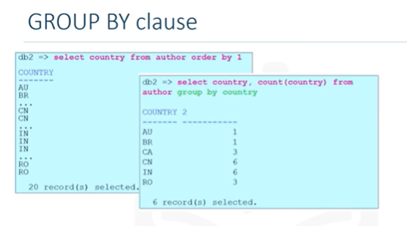

* In this example, countries are grouped and then counted using the COUNT function. Notice the column heading for the 2nd column in the result set. The numeric value 2 displays as a column name because the column name is not directly available in the table. The second column in the result set was calculated by the COUNT function. Instead of using the column name 2, we can assign a column name to the result set. We do this using the AS keyword.
* In this example, we change the derived column name 2 to column name Count using the AS COUNT keyword.

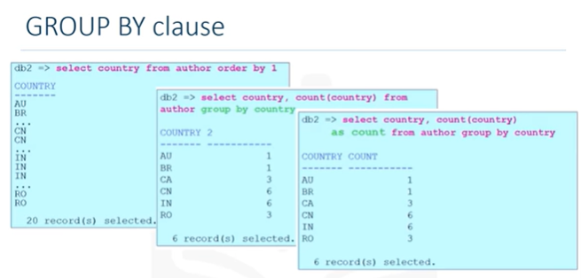

* This helps clarify the meaning of the result set.
* Now that we have the count of authors from different countries, we can further restrict the number of rows by passing some conditions. For example, we can check if there are more than 4 authors from the same country. To set a condition to a GROUP BY clause, we use the keyword HAVING.
* The HAVING clause is used in combination with the GROUP BY clause. It is very important to note that the WHERE clause is for the entire result set, but the HAVING clause works only with the GROUP BY clause. To check if there are more than 4 authors from the same country, we add the following to the SELECT statement: HAVING Count Country> 4.

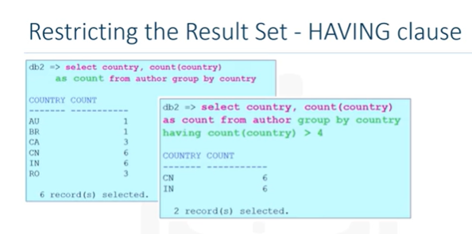

* Only countries that have 5 or more authors from that country are listed in the result set. In this example, those countries are China with 6 authors, and India also with 6 authors.

## Lab 4

# **Exercise 1: String Patterns**

In this exercise, you will go through some SQL problems on String Patterns.

1. Problem:

Retrieve all employees whose address is in Elgin,IL.

Solution

SELECT F_NAME , L_NAME

FROM EMPLOYEES

WHERE ADDRESS LIKE '%Elgin,IL%';

Output

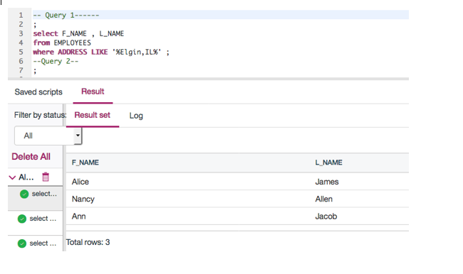

1. Problem:

Retrieve all employees who were born during the 1970's.

Solution

SELECT F_NAME , L_NAME

FROM EMPLOYEES

WHERE B_DATE LIKE '197%';

Output

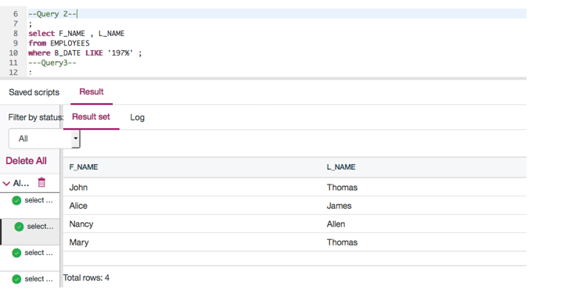

1. Problem:

Retrieve all employees in department 5 whose salary is between 60000 and 70000.

Output

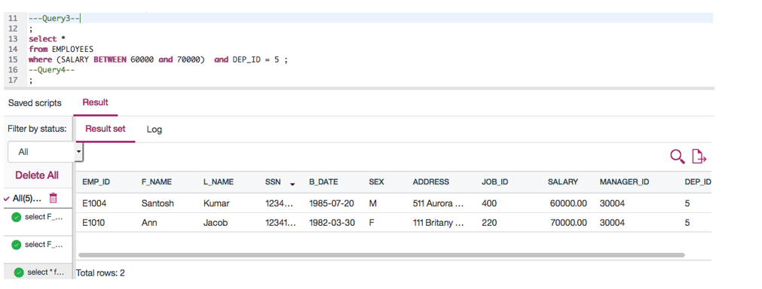

# **Exercise 2: Sorting**

In this exercise, you will go through some SQL problems on Sorting.

1. Problem:

Retrieve a list of employees ordered by department ID.

Output

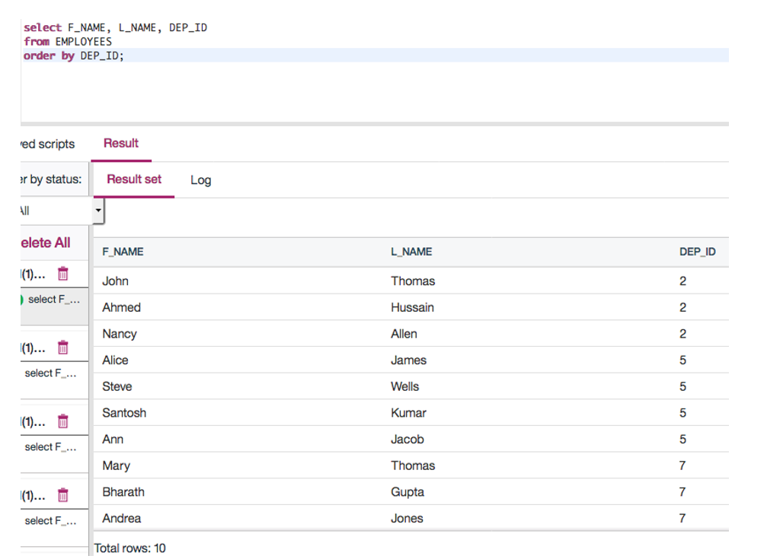

1. Problem:

Retrieve a list of employees ordered in descending order by department ID and within each department ordered alphabetically in descending order by last name.

Output

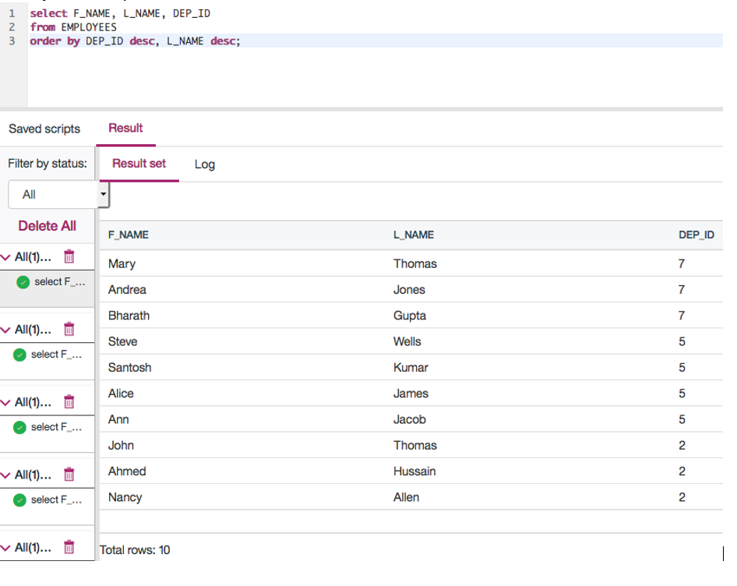

1. (Optional) Problem:

In SQL problem 2 (Exercise 2 Problem 2), use department name instead of department ID. Retrieve a list of employees ordered by department name, and within each department ordered alphabetically in descending order by last name.

Output

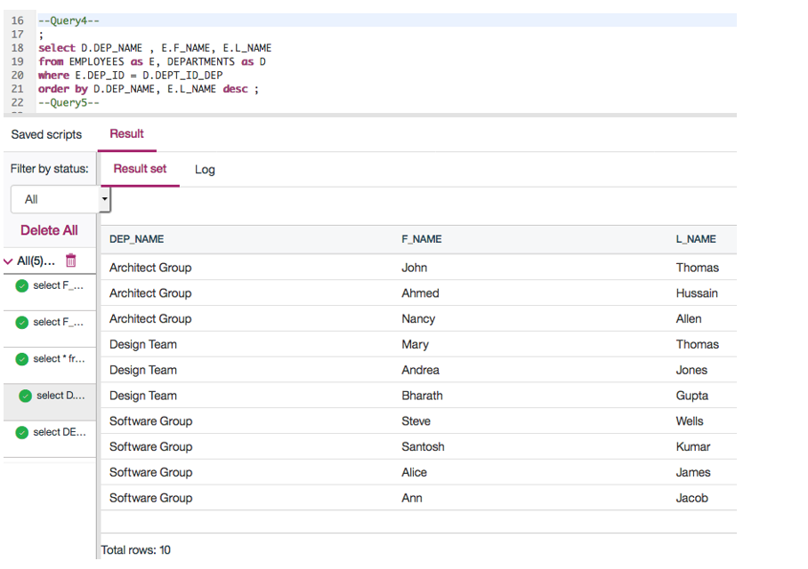

# **Exercise 3: Grouping**

In this exercise, you will go through some SQL problems on Grouping.

**NOTE:** The SQL problems in this exercise involve usage of SQL Aggregate functions AVG and COUNT. COUNT has been covered earlier. AVG is a function that can be used to calculate the Average or Mean of all values of a specified column in the result set. For example, to retrieve the average salary for all employees in the EMPLOYEES table, issue the query: SELECT AVG(SALARY) FROM EMPLOYEES;. You will learn more about AVG and other aggregate functions later in the lecture **Built-in Database Functions**.

1. Problem:

For each department ID retrieve the number of employees in the department.

Output

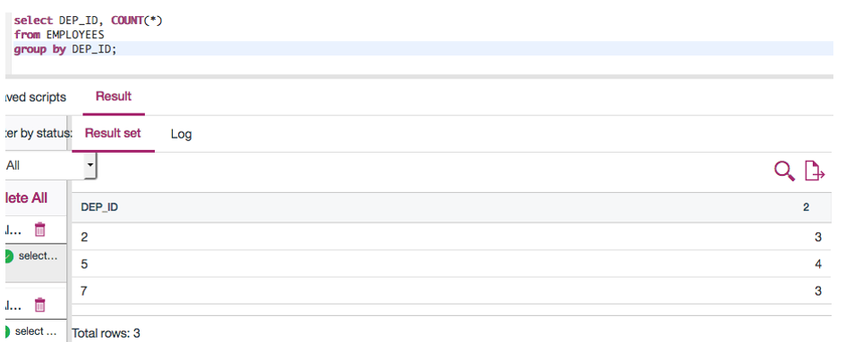

1. Problem:

For each department retrieve the number of employees in the department, and the average employee salary in the department..

Output

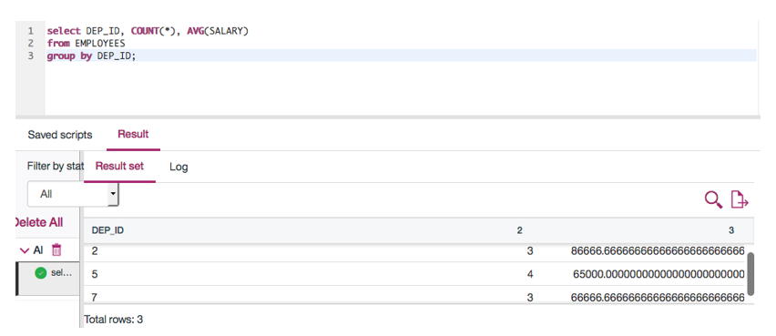

1. Problem:

Label the computed columns in the result set of SQL problem 2 (Exercise 3 Problem 2) as NUM_EMPLOYEES and AVG_SALARY.

Output

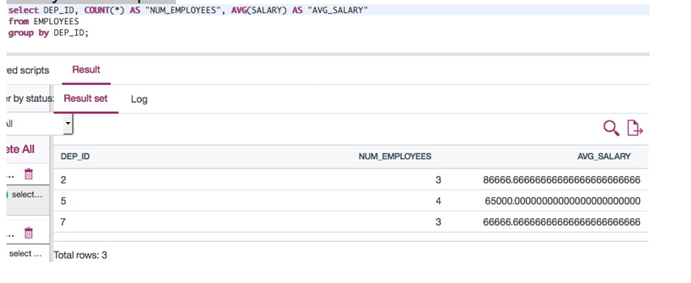

1. Problem:

In SQL problem 3 (Exercise 3 Problem 3), order the result set by Average Salary..

Output

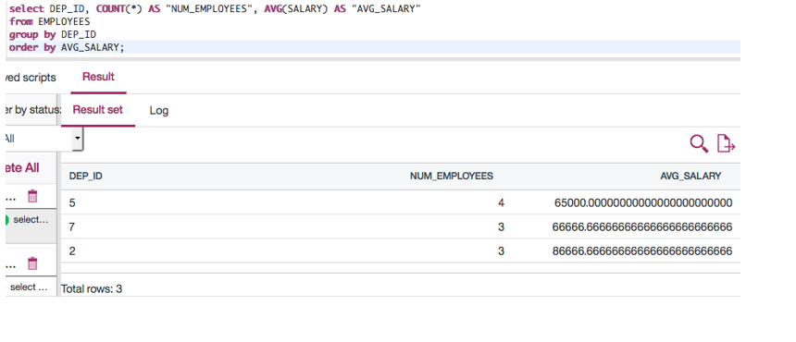

1. Problem:

In SQL problem 4 (Exercise 3 Problem 4), limit the result to departments with fewer than 4 employees.

Solution

**SELECT** DEP_ID, COUNT(*) **AS** "NUM_EMPLOYEES", AVG(SALARY) **AS** "AVG_SALARY"

**FROM** EMPLOYEES

**GROUP** **BY** DEP_ID

**HAVING** count(*) < 4

**ORDER** **BY** AVG_SALARY;

Output

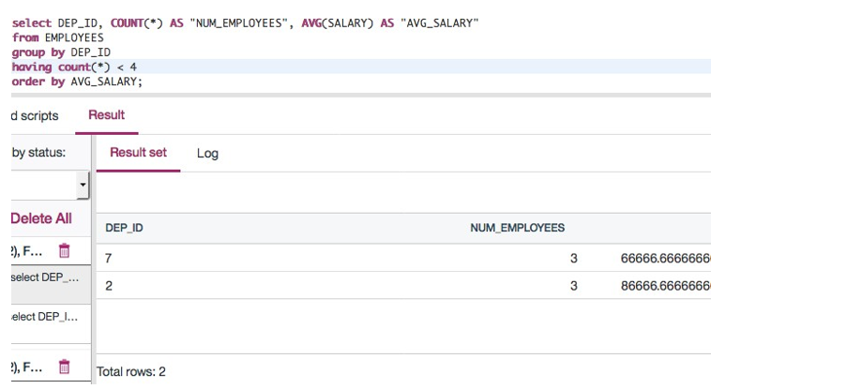

## Test 4

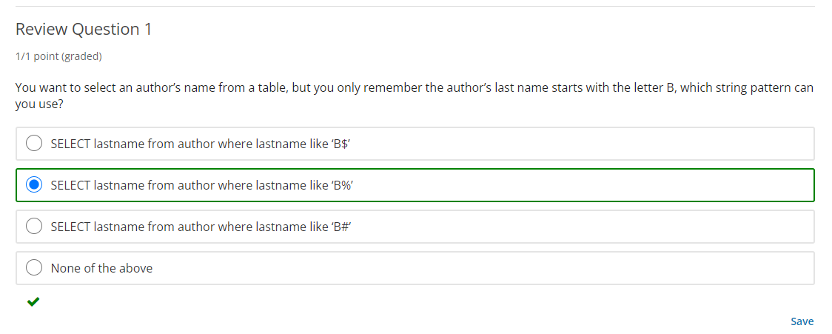

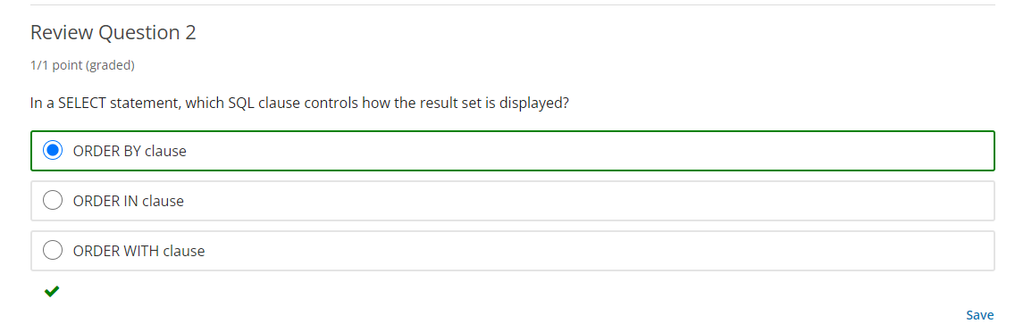

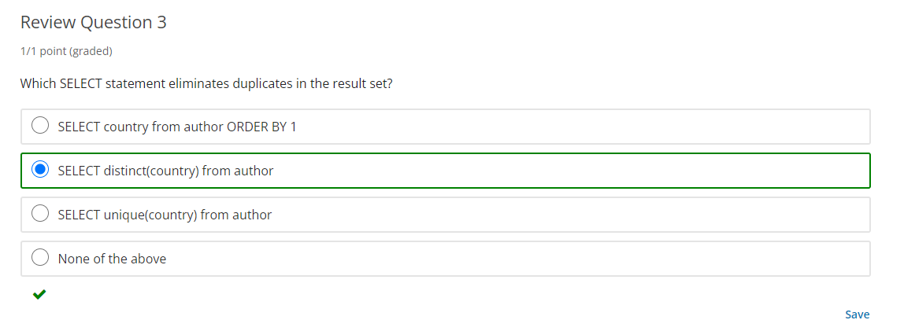

# Module 5: Working with Multiple Tables:

## Learning Objectives:

#### In this lesson you will learn about:

* + - Join Overview
    - Inner Join
    - Outer Join

## JOIN Overview:

* Hello and welcome to working with multiple tables.
* In this video, we will learn about JOINing two tables to create a result set.

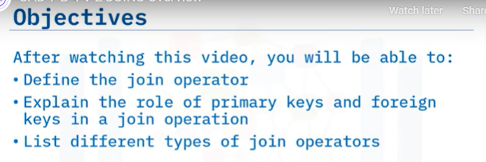

* A simple select statement retrieves data from one or more columns from a single table. The next level of complexity is retrieving data from two or more tables. This leads to multiple possibilities of how the ResultSet is generated.
* To combine data from two tables, we use the JOIN operator. A JOIN combines the rows from two or more tables based on a relationship between certain columns in these tables.

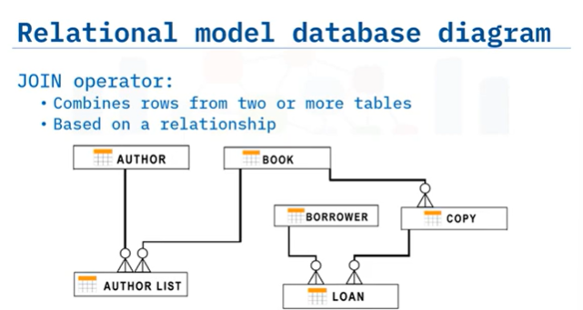

* Based on the book and author entity examples, these are part of a simplified library database model. This entity relationship diagram represents the relational data model for the author and book entity as well as other entities such as borrower, loan, copy, and author list.
* In this model, the information is split into different tables. If you wanted to know which borrower has which copy of a book out on loan, you need to gather data from three tables: the borrower, loan, and copy tables.

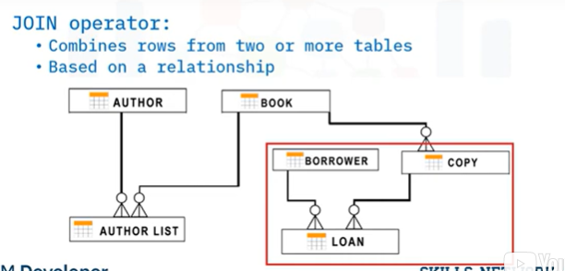

* This is when you need to use the JOIN operator. With the JOIN operator, you are combining data from more than one table based on a relationship between certain columns in these tables.
* So, the first thing you need to do is identify the relationship between those tables. That is, the column or columns in each table that will be used as a link between the tables.
* In this entity relationship diagram, notice the author_ID, book_ID, borrower_ID, and copy_ID had the primary key icon.
* A primary key uniquely identifies each row in a table.

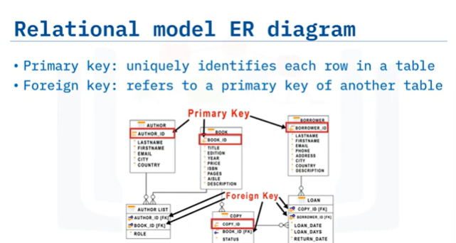

* Notice also the entities on the lower half of the screen- some attributes have FK in brackets next to them.
* For example, the copy entity has attribute book_ID with the FK in brackets. This identifies the foreign key. A foreign key is a set of columns referring to a primary key of another table.
* So, if you wanted to know which borrower has a book out on loan, you need to gather data from the borrower and loan tables. You will need the borrower ID from both tables.

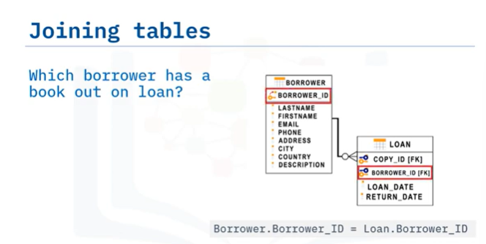

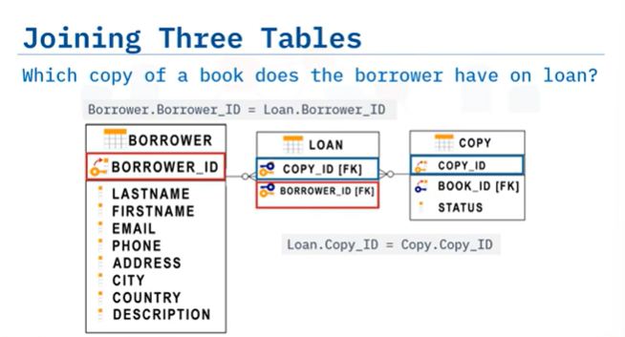

* SQL offers you several different types of JOINs. It all depends on what you are looking for. For example, you can extract a data set corresponding to the intersection of the two tables involved or you can choose a bigger data set.

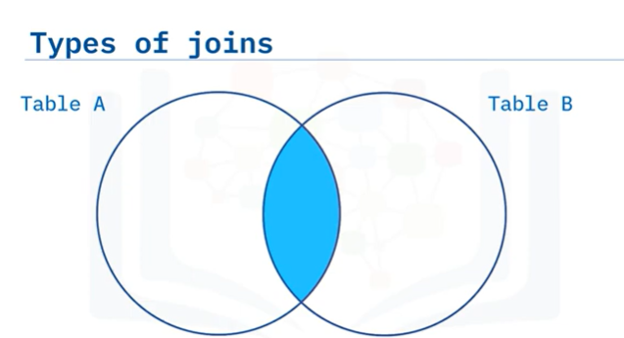

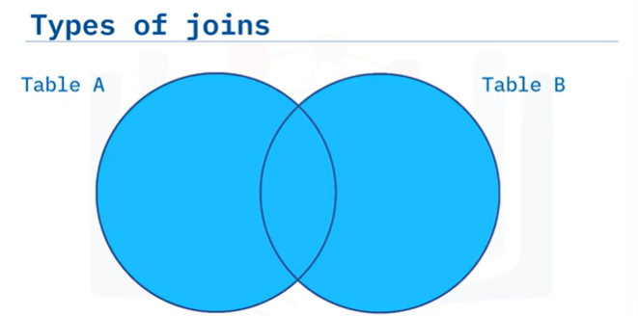

* You can go up to the point of selecting the combination of all the data from those two tables.
* Types

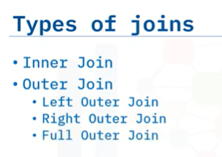

## INNER JOIN

* Hello, and welcome to working with inner joins. In this video, we will learn about joining two tables to create a result set.

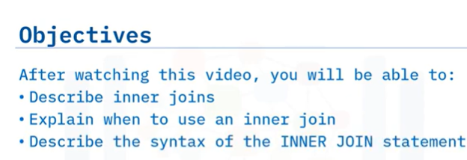

* At the end of this lesson, you will be able to explain the sequel syntax to join two or more tables and interpret the result set.
* A simple select statement retrieves data from one or more columns from a single table. The **next level of complexity is retrieving data from two or more tables. This is referred to as joining tables.**
* A join combines the rows from two or more tables based on a relationship between certain columns in these tables.
* There are two types of table joins: **inner join and outer join.**
* The most common type of join is the inner join.
* An inner join matches the results from two tables and displays only the result set that matches the criteria specified in the query. An inner join returns only the rows that match.

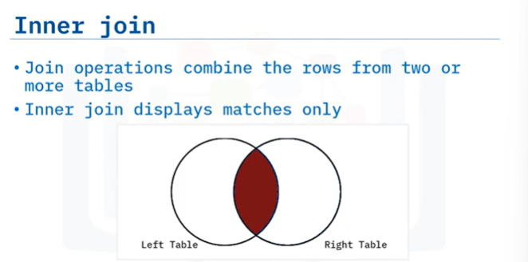

* Usually the PK of one table will exist as the FK of another table
* Based on our simplified library database model, if we want to check the names of people who have borrowed a book, this information is split between two tables. We need to find the names of people from the borrower table, who are listed in the loan table.
* So we need to identify the relationship between the two tables. We do this by identifying a column in each table to link the tables.

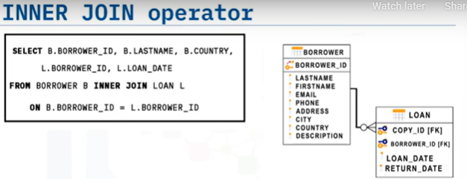

* In this example, we do this by matching the borrower ID, notice that the column borrower ID exists in both the borrower table as the primary key, and the loan table as the foreign key.
* A primary key uniquely identifies each row in a table. A foreign key is a set of columns referring to a primary key of another table.
* We use the inner join operator to match occurrences of the borrower ID in the borrower table, with occurrences of the borrower ID in the loan table.
* This is the syntax of the select statement for an inner join. In the from clause, we identify the borrower table as B, and the loan table as L. For this join, we select borrower ID, last name, and country from the borrower table, and borrower ID, and the loan date from the loan table on the condition that the borrower ID in the borrower table is equal to the borrower ID in the loan table.

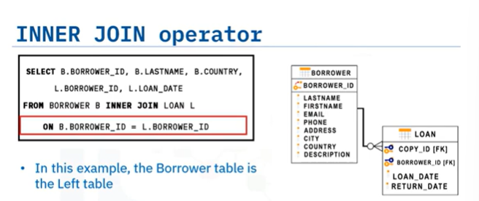

* Notice that in this join each column name is prefixed with either the letter B or L**. In sequel, this prefect is referred to as an alias.**
* Using an alias is much easier than rewriting the whole table name. And here is the result set.
* The result set shows the rows from both tables that have the same borrower ID.

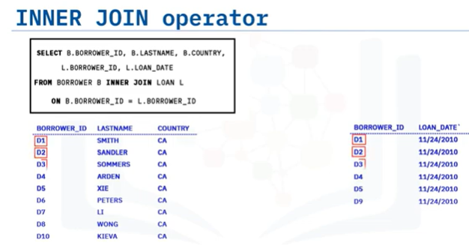

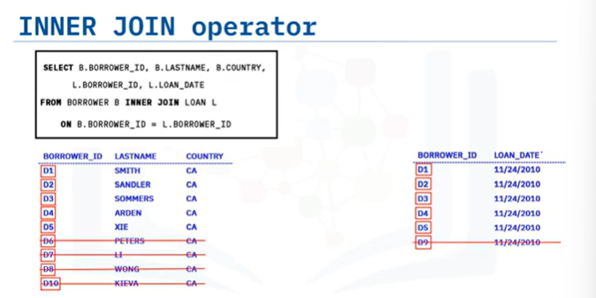

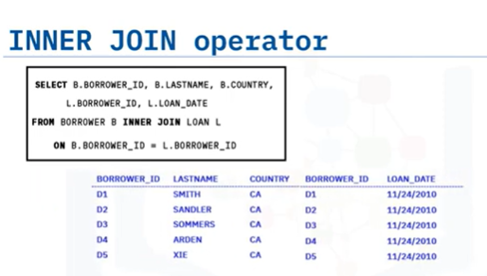

* So far, we have seen an example of combining two tables. But what if you need to combine data from three or more different tables? You simply add new joins to the sequel statement. For example, we want to know which borrowers have a book on loan, but we also want to know which copy of the book they have. This is how the three tables relate to each other. In this case, we join the tables two by two.
* First we join the information from the borrower table and the loan table where the borrower IDs match. Then, we join the information from the loan table and the copy table with a copy IDs match.
* We select the last name from the borrower table, the copy ID from the loan table, and the status from the copy table. And here is the result set. We see the name of the borrower, the ID of each book, and the status they have. There are five books on loan.
* If you wanted to add more tables, you simply add new joins to the sequel statement.

## OUTER JOIN

* Welcome to Outer Join. After watching this video, you will be able to:

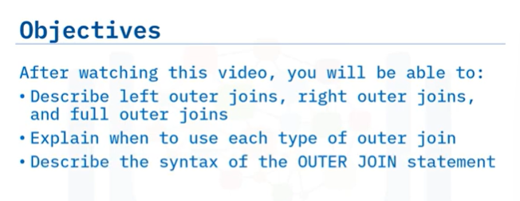

* Outer joins, like inner joins, return the rows from each table that have matching values in the join columns.
* Unlike inner joins, outer joins also return the rows that do not have a match between the tables.
* SQL offers you three types of outer joins: left outer join, right outer join and full outer join.
* In a left outer join, all the rows from the first table (on the left side of the join predicate) are included, and only the matching rows from the second table (on the right side of the join predicate).

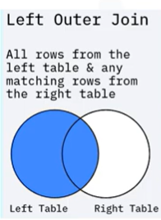

* In this diagram, a Left Join matches all the rows from the left table and combines the information with rows from the right table that match the criteria specified in the query.
* In a right outer join, all the rows from the first table (on the left side of the join predicate) are included, and only the matching rows from the second table (on the right side of the join predicate).

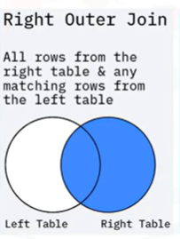

* In this diagram, a Right Join matches all the rows from the right table and combines the information with rows from the left table that match the criteria specified in the query.
* A full join returns all rows from both the right table and the left table. So, the FULL JOIN can return a very large result set.

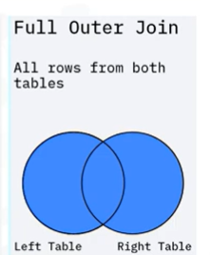

* In this diagram, the result set of a RIGHT JOIN is all rows from both tables matching the criteria specified in the query, plus all non-matching rows from the RIGHT table.
* This is the syntax of the SELECT statement for a LEFT JOIN.

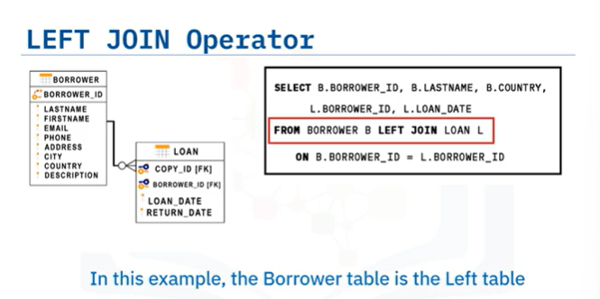

* In this example, the Borrower table is the first table specified in the FROM clause of the SELECT statement, so the Borrower table is the LEFT table, and the Loan table is the RIGHT table. In the FROM clause, Borrower is listed on the left side of the join operator, therefore you will select all rows from the Borrower table and combine them with the contents of the Loan table based on the criteria specified in the query. In this example, the criteria is the BORROWER ID column.
* For a LEFT OUTER JOIN, simply called a LEFT JOIN, you will select the following columns from the Borrower table: BorrowerID, LastName, and Country, and you will also select the following columns from the Loan table: BorrowerID, and LoanDate. The LEFT JOIN selects each BORROWER ID in the Borrower table and displays the LoanDate from the Loan table.
* The result set shows each Borrower ID from the borrower table, and the loan date for that borrower. There is no loan date for the last three rows, so the borrower ID and loan date show null values.

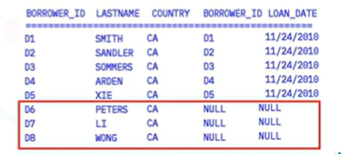

* This is the syntax of the SELECT statement for a RIGHT JOIN.

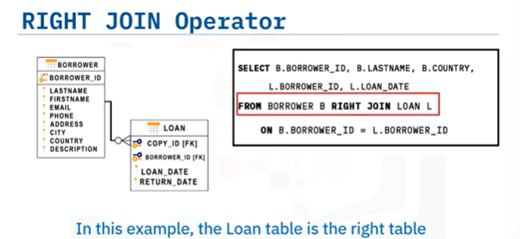

* In this example, the Borrower table is the first table specified in the FROM clause of the SELECT statement, so the Borrower table is the LEFT table, and the Loan table is the RIGHT table.
* In the FROM clause, the Loan table is listed on the right side of the join operator, therefore you will select all rows from the Loan table and combine them with the contents of the Borrower table based on the criteria specified in the query.
* In this example, the criteria is the BORROWER_ID column.
* For a RIGHT JOIN, you will select the following columns from the Loan table: Borrower_ID, and LoanDate, and you will also select the following columns from the Borrower table: Borrower_ID, LastName, and Country where the Borrower_ID in the Loan table matches the Borrower_ID in the Borrower table.
* The result set shows each Borrower ID from the Loan table and the Loan Date for that Borrower, where the Borrower ID in the Loan table also exists in the Borrower table.
* For the last row, there is no matching row in the borrower table, so the Borrower_ID, Lastname, and Country show null values.

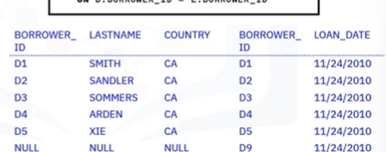

* This could indicate a problem for the library; it indicates there is a book on loan to an unknown person.
* This is the syntax of the SELECT statement for a FULL JOIN.

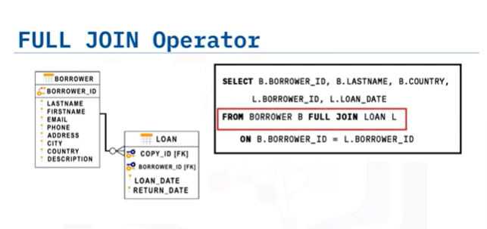

* For a FULL JOIN, you select all rows from the Borrower table and all rows from the Loan table.The result set shows all eight records from the Borrower table listed with the corresponding data from the Loan table.

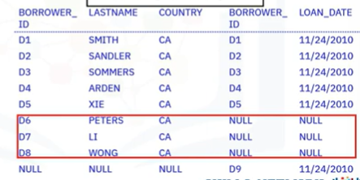

* Once again, three rows return a NULL value because Borrowers Peters, Li, and Wong have never taken a book out on loan. The last row returns values for Borrower_ID and Loan_Date from the Laon table, but returns NULLs from the Borrower table.
* In this instance, there is no match in the Borrower table – the borrower of this book is unknown.

## Lab 5

# **Exercise**

1. Problem:

Select the names and job start dates of all employees who work for the department number 5.

Solution

select E.F_NAME,E.L_NAME, JH.START_DATE

from EMPLOYEES as E

INNER JOIN JOB_HISTORY as JH on E.EMP_ID=JH.EMPL_ID

where E.DEP_ID ='5';

Output

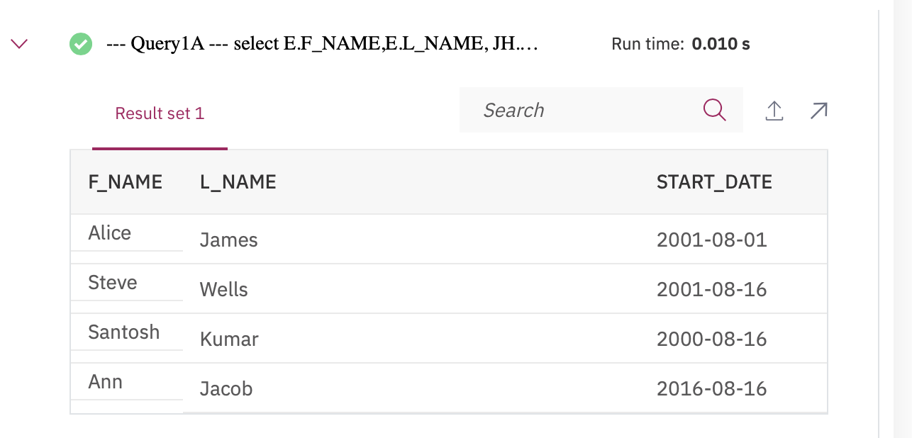

1. Problem:

Select the names, job start dates, and job titles of all employees who work for the department number 5.

Solution

select E.F_NAME,E.L_NAME, JH.START_DATE, J.JOB_TITLE

from EMPLOYEES as E

INNER JOIN JOB_HISTORY as JH on E.EMP_ID=JH.EMPL_ID

INNER JOIN JOBS as J on E.JOB_ID=J.JOB_IDENT

where E.DEP_ID ='5';

Output

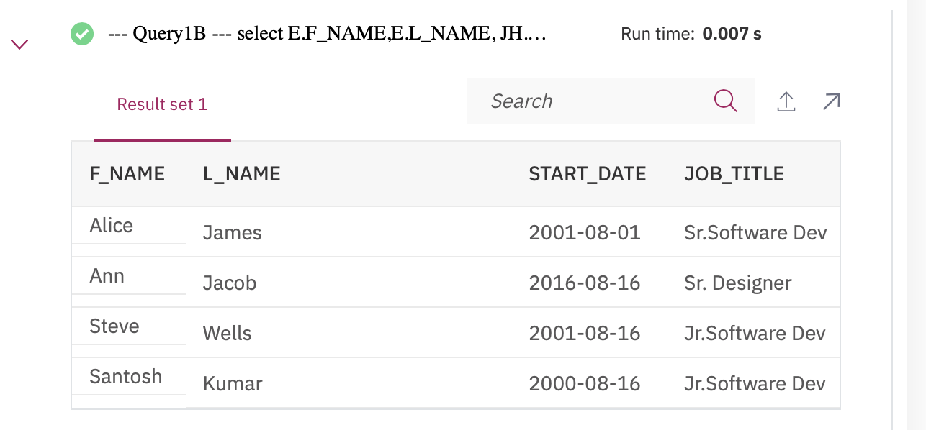

1. Problem:

Perform a Left Outer Join on the EMPLOYEES and DEPARTMENT tables and select employee id, last name, department id and department name for all employees.

Solution

select E.EMP_ID,E.L_NAME,E.DEP_ID,D.DEP_NAME

from EMPLOYEES AS E

LEFT OUTER JOIN DEPARTMENTS AS D ON E.DEP_ID=D.DEPT_ID_DEP;

Output

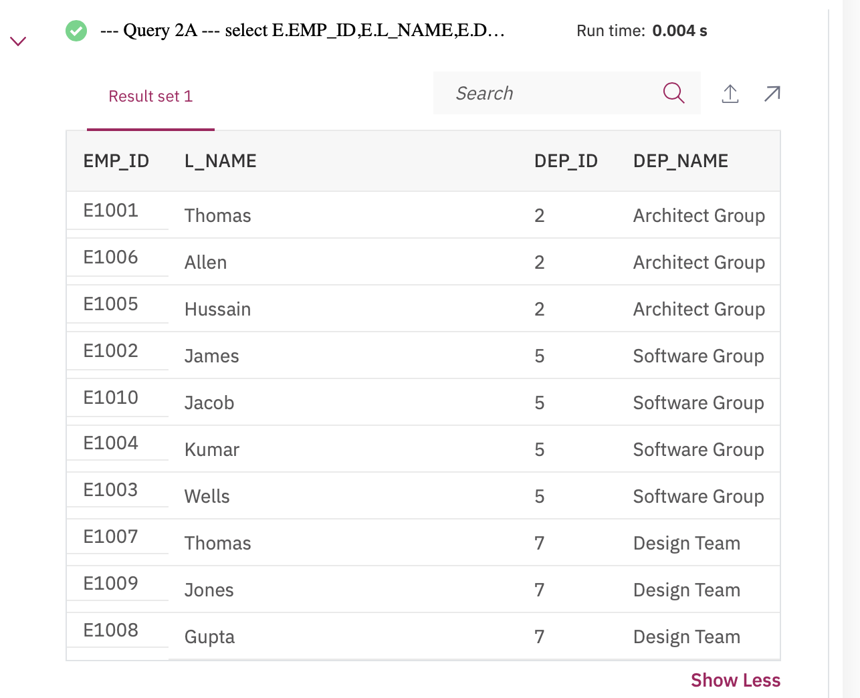

1. Problem:

Re-write the previous query but limit the result set to include only the rows for employees born before 1980.

Solution

select E.EMP_ID,E.L_NAME,E.DEP_ID,D.DEP_NAME

from EMPLOYEES AS E

LEFT OUTER JOIN DEPARTMENTS AS D ON E.DEP_ID=D.DEPT_ID_DEP

where YEAR(E.B_DATE) < 1980;

Output

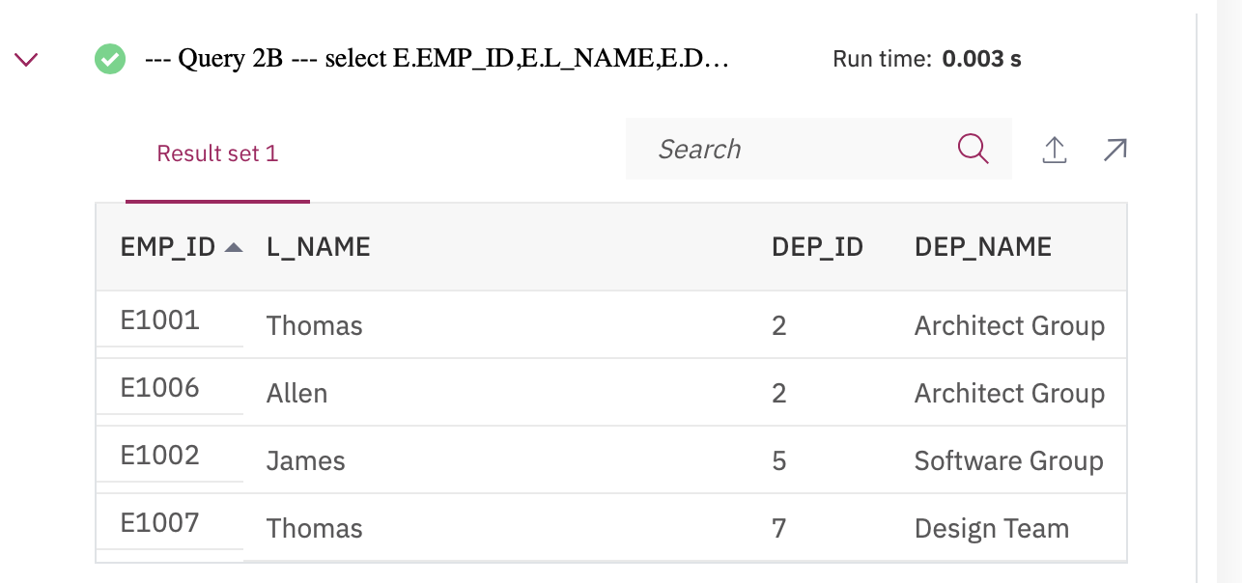

1. Problem:

Re-write the previous query but have the result set include all the employees but department names for only the employees who were born before 1980

Solution

select E.EMP_ID,E.L_NAME,E.DEP_ID,D.DEP_NAME

from EMPLOYEES AS E

LEFT OUTER JOIN DEPARTMENTS AS D ON E.DEP_ID=D.DEPT_ID_DEP

AND YEAR(E.B_DATE) < 1980;

Output

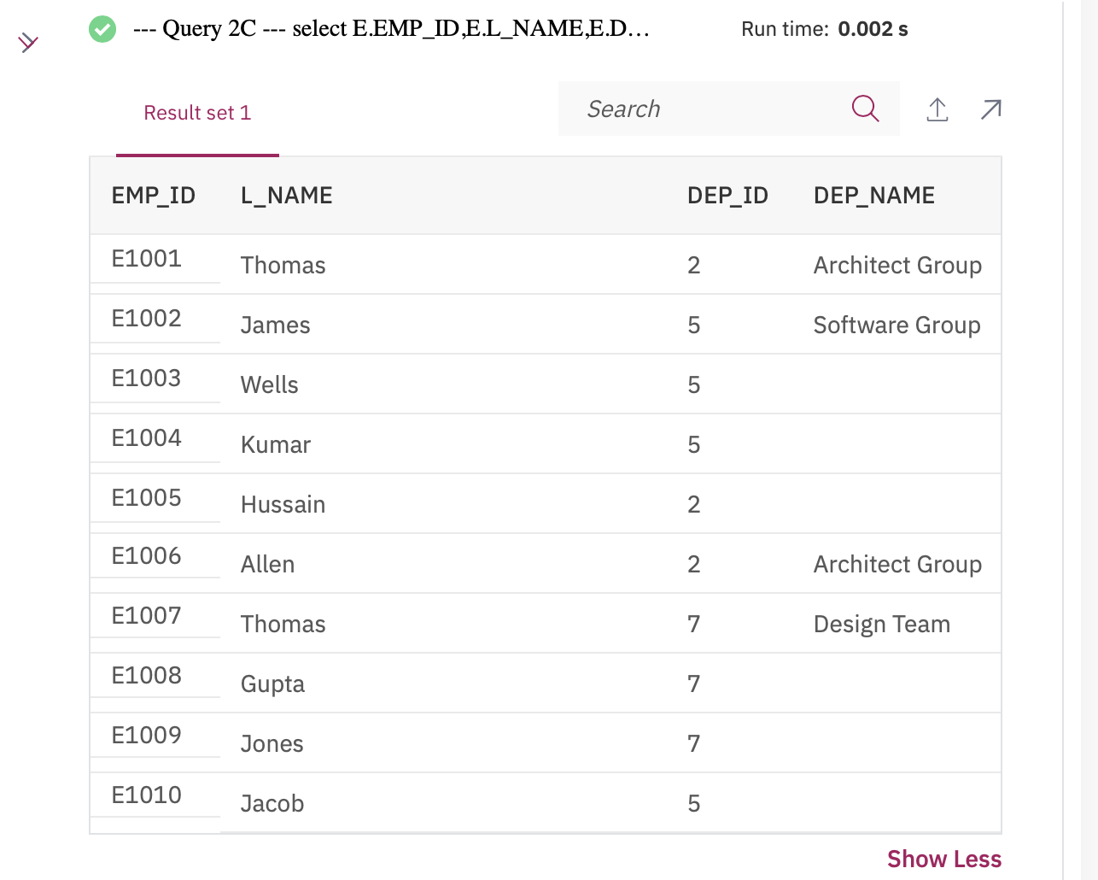

1. Problem:

Perform a Full Join on the EMPLOYEES and DEPARTMENT tables and select the First name, Last name and Department name of all employees.

Solution

select E.F_NAME,E.L_NAME,D.DEP_NAME

from EMPLOYEES AS E

FULL OUTER JOIN DEPARTMENTS AS D ON E.DEP_ID=D.DEPT_ID_DEP;

Output

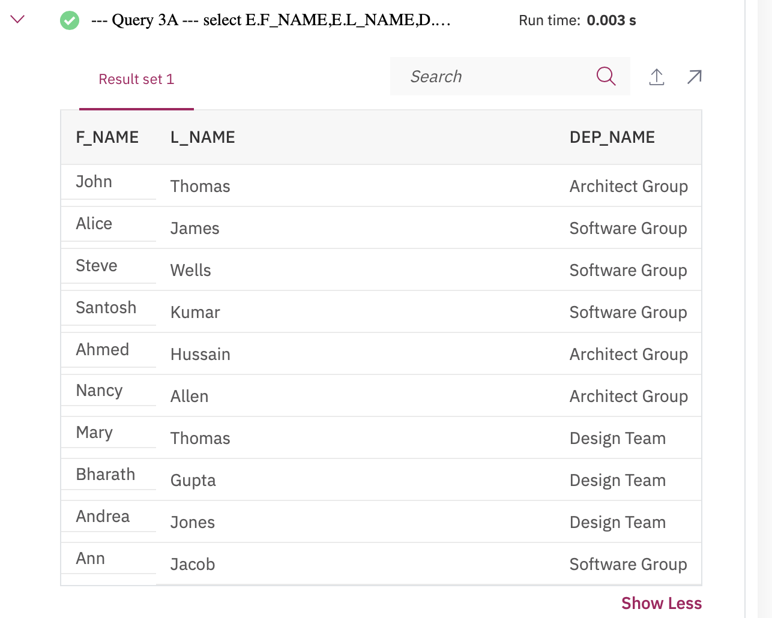

1. Problem:

Re-write the previous query but have the result set include all employee names but department id and department names only for male employees.

Solution

select E.F_NAME,E.L_NAME,D.DEPT_ID_DEP, D.DEP_NAME

from EMPLOYEES AS E

FULL OUTER JOIN DEPARTMENTS AS D ON E.DEP_ID=D.DEPT_ID_DEP AND E.SEX = 'M';

Output

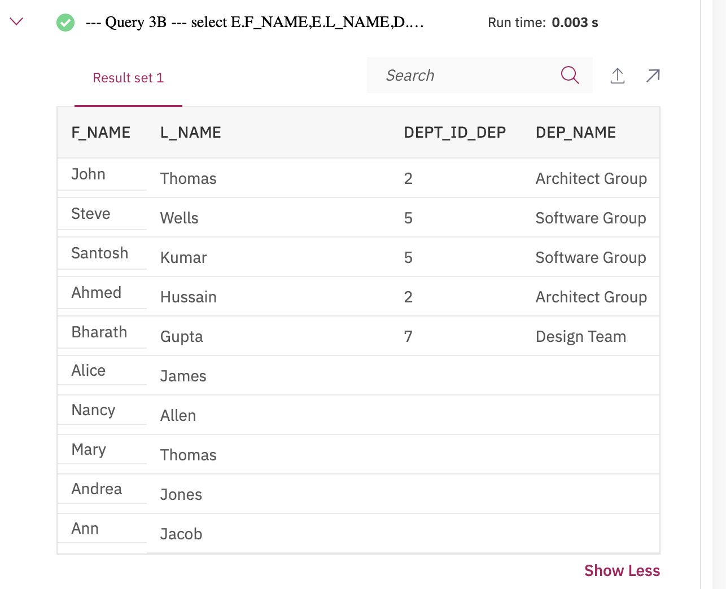

## Test 5

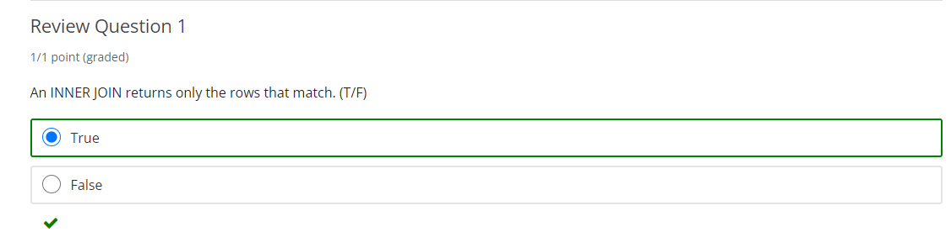

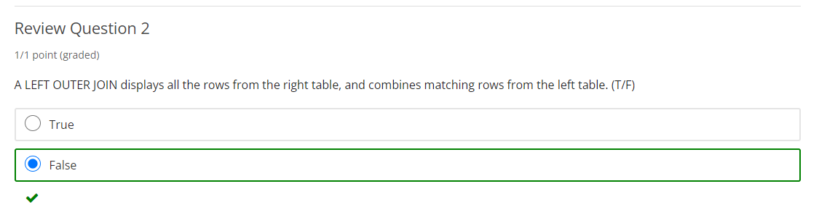

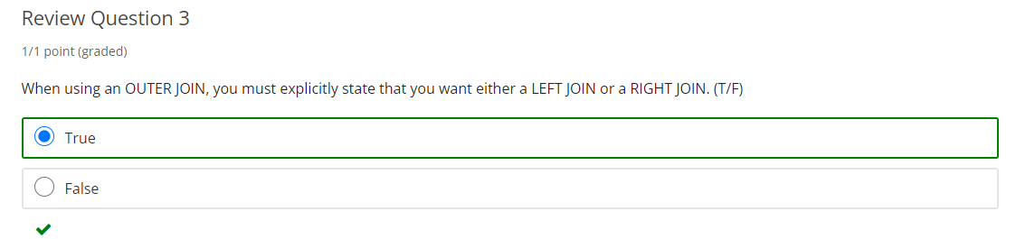

# Final Exam: